It is worse than you think: Implications of spatial and trophic overlap between juvenile salmon and Sablefish in the inshore surface waters of the Northern California Current

**Elizabeth A. Daly1*, Brandon E. Chasco2, Cheryl A. Morgan1, Brian J. Burke3, and Kaitlyn E. Osborne4**

1Cooperative Institute for Marine Ecosystem and Resources Studies, Oregon State University, Newport, Oregon 97365, USA

2National Oceanic and Atmospheric Administration, National Marine Fisheries Service, Fish Ecology Division, Newport, Oregon 97365, USA

3National Oceanic and Atmospheric Administration, National Marine Fisheries Service, Fish Ecology Division, Seattle, Washington 98112, USA

4 BlueSunInc, Newport, Oregon 97365, USA

_________________________________

*Current address, Newport, Oregon

Corresponding author: E. A. Daly, [Elizabeth.Daly@oregonstate.edu](mailto:Elizabeth.Daly@oregonstate.edu)

To be submitted to *Marine and Coastal Fisheries*

# Abstract

Interactions between protected and commercial species remains an area of concern for management agencies. An unusually high abundance of juvenile Sablefish in nearshore marine waters in the northern California Current in 2020 were in spatial and trophic overlap with protected populations of juvenile salmon. Due to feeding advantages exhibited by the Sablefish, the juvenile salmon would be worse off competitively during a critical phase of their early life history. The 2020 index of abundance of juvenile Sablefish showed an 8.6-fold higher relative to any of the other 24 years and there was an overall positive relationship between encounter rates of Sablefish and temperature. The Sablefish were more abundant than the juvenile salmon for which the survey was designed. Sablefish were caught at the most inshore stations and along all transects, and showed the highest spatial overlap with Coho Salmon, followed by yearling Chinook Salmon and had the least spatial overlap with subyearling Chinook Salmon while juvenile salmon had a more inshore distribution in 2020 relative to other surveys. Juvenile Sablefish ate similar prey taxa as juvenile salmon, such as juvenile rockfish, crab larvae, and krill, though there were notable diet differences. Juvenile Sablefish exhibited a significant ontogenetic diet and energetic shift, and even the smallest juvenile Sablefish caught (60-80 mm) were piscivorous. Juvenile Sablefish had significantly higher feeding intensity than juvenile salmon, with 7% of Sablefish consuming greater than 10% of their body weight, while none of the salmon had a stomach fullness higher than 7.2%. Juvenile salmon, caught in the presence of juvenile Sablefish, had lower feeding intensity than at stations where there were no Sablefish present. Sablefish were able to consume larger fish prey at a smaller size than juvenile salmon. Climate driven increases in coastal ocean temperatures could be changing juvenile Sablefish distribution, resulting in higher spatial and trophic overlap with juvenile Pacific salmon. With some salmon populations already predicted to decrease primarily due to warmer ocean temperatures, yet their outlook is worse than we think if consider trophic interactions with a competitor like juvenile Sablefish. Juvenile salmon, in direct competition for food resources, would be the loser relative to the more numerous juvenile Sablefish that ate similar, larger, and more prey.

**Key Words:** juvenile salmon, juvenile Sablefish, ontogenetic diet, overlap, trophic, competition, climate change

# Introduction

The epipelagic zone of the Northern California Current (NCC) is a highly productive system, primarily due to the spring and summer upwelling of nutrient rich waters into the coastal waters. Micro-nekton, such as krill, cephalopods, crustaceans, and many fishes utilize the upper waters of the productive epipelagic zone as larvae and juveniles (Brodeur et al. 2019). While numerous populations of juvenile salmon in the NCC are stable or increasing, many are in decline and are listed as threatened or endangered under the Endangered Species Act. United States commercial landings of Pacific salmon in 2019 were in excess of $700 million ([www.fishereis.noaa.gov](http://www.fishereis.noaa.gov); last accessed Jan. 2023). Juvenile salmon from the Columbia River enter the NCC in spring and summer and spend weeks to several months feeding and growing in the coastal epipelagic waters of Oregon and Washington (Weitkamp 2010; Tomaro et al. 2012). The growth of juvenile Coho (*Oncorhynchus kisutch*) and Chinook (*O. tshawytscha)* salmon during their early marine phase is critical to their survival (Pearcy 1992) and early marine growth and survival has been shown to be strongly impacted by bottom up processes of prey availability and quality and environmental conditions such as ocean upwelling and temperature (Logerwell et al. 2003; Beamish et al. 2004; Burke et al. 2013; Daly et al. 2013; Claiborne et al. 2021; Crozier et al. 2021). Sablefish (*Anoplopoma fimbria*) are a marine demersal fish of high commercial importance found along the west coast of the United States and are one of the highest valued fish per pound due to their rich oil content, with commercial fisheries landings valued at approximately $90 million in 2019 ([www.fishereis.noaa.gov](http://www.fishereis.noaa.gov); last accessed Jan. 2023). Interannual variation in Sablefish recruitment has been linked with oceanographic, growth, and prey conditions during the egg and larval stage and year class strength can periodically be 5-10 times higher between years (McFarlane and Beamish 1983; Kendall Jr and Matarese 1987; Schirripa and Colbert 2006; Sogard 2011; Tolimieri et al. 2018; Haltuch et al. 2019).

Novel interactions between managed species in the nearshore marine environment are increasing as a result of changes in atmospheric and ocean processes, which can have implications for fisheries management and conservation (Poloczanska et al. 2016). Ecosystem management of multiple species requires understanding complex ecological interactions in order to ensure that there are sustainable resources for managed populations. Species-specific characteristics, such as diet composition, growth rates, potential competitors, and habitat selection, need to be understood in order to successfully account for climate driven changes in order to develop effective management strategies (Weiskopf et al. 2020). Competitive interactions can adversely affect the growth and survival rates of marine fishes in their early life history stages. During this critical growth period, juveniles may compete with other individuals of their own species as well as with different species for food resources. When food availability is limited, locally or broadly, the individuals that are better adapted to obtain and utilize resources tend to have a competitive advantage and are more likely to grow faster and survive (Akinori et al. 2003; Le Pape and Bonhommeau 2015; Fennie et al. 2023). Fish populations with intrinsically higher growth rates, or dominant feeding behaviors, may outcompete weaker individuals for resources, which may lead to increased vulnerability to predation and higher mortality rates for the less competitive species. Competition is difficult to quantify, especially within an enormous landscape such as the ocean, where data are highly limited.

The distribution, size, and diets of juvenile Coho and Chinook Salmon has been well studied in the NCC. Juvenile salmon typically reside in the top 10-20 m of the epipelagic zone of the ocean (Emmett et al. 2004), and are generally sampled close to shore (Peterson et al. 2010). The average size of subyearling Chinook Salmon during June of their early marine residency is 108 mm Fork Length (FL), and approximately 185 mm for yearling Chinook Salmon and on average 150 to 190 mm for juvenile Coho Salmon that are sampled in the ocean in June. Both Chinook and Coho Salmon exhibit significant interannual variability in their size as well as between hatchery and unmarked (Brodeur et al. 2007; Daly et al. 2012; Weitkamp et al. 2012). Juvenile Coho and Chinook Salmon diets eat primarily consist of juvenile fishes, krill, and crab megalopae, and to a lesser degree, fish larvae, copepods, amphipods, pteropods, and insects (Brodeur et al. 2007; Miller et al. 2010; Hertz et al. 2015; Dale et al. 2017). As they grow in the marine environment, they become increasingly piscivorous and many of the taxa that they consume reside in the surface neustonic layer (Brodeur et al. 1987; Schabetsberger et al. 2003; Daly et al. 2009).

The distribution, size, and diets of larval and juvenile Sablefish has been studied in the NCC, but not to the extent that juvenile salmon have been studied. Adult Sablefish spawn pelagic eggs typically at ocean depths >300 m near the edge of the continental shelf during winter. The eggs and newly hatched larvae remain in deep waters until in late winter to early spring when they rise to the surface waters, at approximately 8-11 mm Standard Length (SL) and are thus obligate neustonic dwellers (Kendall Jr and Matarese 1987; Shenker 1988; Tolimieri et al. 2018). Larval and small juvenile Sablefish (10-50 mm SL) are typically found at the surface 5 to 370 km from (Kendall and Clark 1982; Shenker 1988). Juveniles that are > 100 mm FL are in the top 15 to 60 m surface waters, and have been sampled 20 to 60 km from shore in June, and by September are closer to shore when most individuals are > 200 mm FL (Brodeur and Pearcy 1986; Brodeur et al. 2004). By late fall, Sablefish become demersal and move back offshore (Tolimieri et al. 2018).

Surface caught larval (10-30 mm SL) exhibit distinct ontogenetic diet shifts from a diet almost singularly made up of small copepods to an increasingly diverse consumption of small to large copepods as well as krill and amphipod larvae (Grover and Olla 1987). Diets of larger surface caught juvenile Sablefish are a mixture of juvenile fish, crab larvae, krill, and gelatinous zooplankton with low to moderate diet overlap with salmon (Brodeur and Pearcy 1992; Sigler et al. 2001; Miller and Brodeur 2007). Juvenile (> 35 mm SL) Sablefish grow approximately 2 mm/day during this phase of their life (Boehlert and Yoklavich 1985; Kendall Jr and Matarese 1987) have one of the fastest growth rates recorded for juvenile fish (Shenker and Olla 1986; Sogard and Olla 2001). While in the neuston juvenile Sablefish feed consistently at maximum consumption if prey are available and exhibit an extreme foraging strategy and rapid growth (Sogard and Olla 2002). During this first summer, juvenile Sablefish can be 50 mm in July and grow to 280 mm by November (McFarlane and Beamish 1983).

Some Pacific salmon populations, such as Chinook Salmon*,* are predicted to decline dramatically by 83-90% as a direct result of climate change during their marine phase (Crozier et al. 2021), while Sablefish populations are predicted to increase (Haltuch et al. 2019). The prediction that Sablefish populations may do well under various climate change scenarios may be primarily due to their intense foraging strategy as young of the year fish (Sogard and Olla 2002; Sogard and Spencer 2004; Haltuch et al. 2019; Krieger et al. 2020). When juvenile salmon and Sablefish overlap, there may be direct and/or apparent competition, or even predation (Holt 1977) with greater potential impact on juvenile salmon, which are slower growing. Yet we have little information in this area. Since 1998, there has been an ongoing ocean trawl survey targeting juvenile salmonids conducted in the surface waters of the epipelagic zone in late June in the nearshore to shelf waters of Oregon and Washington (Morgan et al. 2019). Juvenile salmon are identified, measured, and retained for further trophic analysis in the lab (as well as other metrics), captured juvenile Sablefish are typically identified, measured, and quantified at sea and then released, however in 2020, a subsample of juvenile Sablefish from each station was frozen and returned for further analysis. In order to further our understanding of potential interactions between juvenile salmon and Sablefish during a critical life-history stage, we modeled spatio-temporal encounter rates and indices of abundance of juvenile salmon and Sablefish along with temperature, diet overlap, stomach fullness, and fish prey/predator size ratios between juvenile Sablefish and salmon.

# Methods

*Data collection*

Surface trawl surveys have been conducted during the latter part of June for 25 years (1998 to 2022) in Oregon and Washington coastal waters as part of the Juvenile Salmon and Ocean Ecosystem Survey (JSOES) by the Estuarine and Ocean Ecology Program of the National Oceanic and Atmospheric Administration and Oregon State University (NOAA and OSU; Fig. 1). Sampling stations were 3-5 km apart and start inshore at 30-40 m bottom depth and offshore to the coastal shelf. Established transects run perpendicular to the coast and are spaced ~ 30-50 km apart, primarily located between 44-48.5° N and 124-125° W. At each station, we measured temperature with a conductivity–temperature–depth instrument to within 5 m of the bottom or a depth of 200 m. We used temperatures at 3m water depth for this analysis. Additionally, at each station, a Nordic 264 pelagic rope trawl with a mouth opening of 30 m wide and 20 m deep and a 0.8-cm cod-end liner was towed at the surface during daylight hours for 30 min at a ship speed of ~ 6 km h-1 (3.2 kts). All sampled nekton were identified, quantified, and up to 50 were measured. Juvenile salmon were individually tagged and frozen, and a sub-sample of the Sablefish were bulk frozen (2020 only). To examine growth of age-zero Sablefish throughout their first marine summer, we used length data from May, June, and September JSOES surveys. For all other analyses, we used June survey data only. In the laboratory, the salmon and Sablefish were individually weighed and stomachs were removed, frozen, and analyzed. Chinook Salmon were classified by length into the life history stages of subyearling and yearling using size criteria from Pearcy and Fisher (1990), and our own work, and all juvenile Coho Salmon were classified as yearling based on known life history strategies.

*Size and Energy density analyses*

Interannual changes in size of juvenile Sablefish were tested using the nonparametric Kruskal-Wallis test for each year with significance of P < 0.05 and was used due to non-normally distributed data. Energy density was calculated on a subsample of juvenile Sablefish (n=56; 77-178 mm FL) using a Parr 6725 semi-micro calorimeter (Parr Instruments, Moline, IL, United States). To prepare samples for calorimetry, whole body minus the stomach of each sample was placed into a desiccating oven at approximately 60° C for 72 hours, recording the wet weight (ww) of the tissue before and after desiccation. Dried samples were then pulverized into a homogenous powder before pressing into pellets ranging in size from 17 to 84 mg. Replicates of each fish were ran then averaged together with replicates differing by 1.6 ( ± 1.3%). Standardization of bombs occurred every 10 runs using 200 mg benzoic acid pellets. Energy density was reported as kJ g-1 wet weight. To test for size-based energetic differences, we grouped the energy density into the size bins identified in the ontogenetic diet differences of fish < 120 mm and ≥ 120 mm.

*Spatial analysis*

We used a generalized linear mixed model (GLMM) to evaluate the relationship of both the encounter rates and densities of Sablefish, yearling and subyearling Chinook, and Coho Salmon. To make inferences about the spatiotemporal distribution between fishes using data from the JSOES unbalanced survey design where the locations and number of sites sampled varies between years (Fig. 1), we used the Vector Autoregressive Spatio-Temporal Model (VAST) package in R – a flexible statistical framework for modeling univariate and multivariate spatiotemporal population processes that include both presence/absence and positive captures (Thorson 2019). For our analysis, we considered a delta log-normal GLMM model, where the encounter probability was modeled with a Bernoulli probability, and positive catches were modeled with a log-normal distribution.

In our VAST model, the encounter probability and positive catches are modeled separately, with analyst-defined inputs for the univariate or multivariate statistical structure of the temporal, spatial, and spatiotemporal deviates. The objective of this analysis is to compare the spatiotemporal similarities between each fishes for the two modeled processes (encounters and positive catches. Additionally, we included a local (3 m water temperature at each trawl location) and a basin-scale (May SSTarc; Johnstone and Mantua 2014) covariate of temperature that may bias juvenile catch rates used to estimate the spatial and spatiotemporal normalized indices of abundance (Maunder et al. 2006; 2020). We chose May SSTarc in order to represent the ocean conditions the month prior to capture of salmon and Sablefish to identify if their distribution (based on encounter rate or positive catches in June) were impacted by large oceanographic conditions, and if their encounter rate or positive catches were impacted at the small scale (station level) using the 3 m water temperature at the time of their capture.

For the encounter model, the intercept (i.e., average expected encounter rate) for each species was assumed to be independent, fixed and constant across all years. Comparisons between fishes over space and time are defined by the covariance matrix for the encounter and positive catch processes. A full rank model would estimate 10 parameters for each of the two process – one variance parameter for each fish and six correlation parameters in the off-diagonal of the covariance matrix. However, limitations in the data forced us to consider a reduced rank model, where the four fishes were reduced to three “categories” for the spatial and spatiotemporal deviations for the two processes; reducing the number of estimated parameters for each covariance matrix from 10 to nine. The temporal differences for the spatiotemporal temporal processes describing encounter rates and positive catches were assumed to be independent and identically distributed which introduced an additional variance parameter. See [https://github.com/bchasco/juv_Sablefish/blob/main/](https://github.com/bchasco/juv_sablefish/blob/main/Aniso.png)VAST_model.r for the R-script used to create the model.

The statistical distributions of the spatial random deviations were defined by Gaussian Markov Random Fields (GMRF) approximated using stochastic partial differentials equations (SPDE) to improve computational efficiency (Lindgren and Rue 2015). VAST is a high level wrapper combining the SPDE approximations for spatial GMRF using the Integrated Nested Laplace Approximation package (INLA; Lindgren and Rue 2015) and optimization routines in the Template Model Builder package (TMB; Kristensen et al. 2016) which uses a Laplace approximation to optimize the marginal maximum likelihood (Kristensen et al. 2016). A full description of the model structure, parameters and derived variables from the VAST model can be found in Thorson (2019). Derived variables from the VAST most germane to our analysis for the four species include: 1) the indices of abundance derived from the integrated estimates of encounter probability, catch densities and the area sampled at each location, and 2) the spatial and spatiotemporal correlation between the species.

We made three additional transformations of the data: 1) to increase interpretability of the range parameter describing spatial decorrelation, the coordinate data were transformed from latitude and longitude to UTM (Universal Transverse Mercator) Zone 10, 2) to improve the uniformity of the triangles in the spatial mesh for estimating the GMRF using the INLA package, the GPS coordinates for each trawl was mapped to a single ‘station’ location, 3) the density of the catches in km2 is equal to the distance towed in km multiplied by 0.02 km - the width of the Nordic trawl net (NMFS 2008), and 4) to improve the estimation speed, we fixed the number of knot locations to 68 - one for each ‘station’ (Supplemental Fig. 2).

*Diet analyses*

We analyzed stomach contents of juvenile salmon and Sablefish in 2020 from freshly thawed stomachs using a dissecting microscope. All retained juvenile Sablefish and yearling Chinook Salmon were analyzed for diet analysis, while a sub-sample of up to10 Coho and 10 subyearling Chinook Salmon diets from each station were analyzed. Stomach contents were identified to the lowest possible taxonomic category and counted and weighed to the nearest 0.001 g. Length of freshly consumed fish prey (up to six per taxa per stomach) were measured to the nearest 1 mm. Diet composition was calculated as percent weight of prey consumed by an individual fish, then averaged by predator and/or size of predator at the station sampled, followed by an overall average of the stations. The diets data were averaged by station prior to analysis due to the high station level auto-correlation in recently consumed prey. Prey were grouped into 18 prey categories, where the taxa or group taxa made up greater than 5% of the diets by weight of prey consumed: unidentified fish (unidentified fish prey), Pacific Herring (*Clupea pallasii*), smelt (family Osmeridae), Pacific Sand Lance (*Ammodytes personatus*), Lingcod (*Ophiodon elongatus*), rockfish (*Sebastes* spp.), sculpin (family Cottidae), other fish [flatfish (family Pleuronectidae), Northern Ronquil (*Ronquilus jordani*), Quillfish (*Ptilichthys goodei*), and Pacific Tomcod (*Microgadus proximus*)], crab megalopae (*Metacarcinus* spp.), crab zoea (*Metacarcinus* spp.), non-*Metcarcinus* crab megalopae, gelatinous zooplankton, unidentified copepods, amphipods (family Hyperiidae and Gammaridae), krill (*Thysanoessa spinifera and Euphausia pacifica*), pteropod (*Limacina helicina*), squid (family Teuthida), and other invertebrates (ostracod, barnacle cyprid, mysid, and shrimp larvae, insects, and polychaetes).

Station average diet composition by weight of prey consumed by juvenile Sablefish and juvenile salmon were evaluated visually via non-metric multidimensional scaling ordination (NMDS) using a pairwise Bray-Curtis similarity matrix. The NMDS analysis was completed using the vegan, mass, permute, labdsv packages in R. Dietary overlap between juvenile Sablefish and the salmon was calculated at the lowest possible taxonomic level using the Percent Similarity Index (PSI):

100

5

.

0

1

1















−

−







*n*

*i*

*jk*

*ik*

*ij*

*p*

*p*

*D*

PSI

where pik is the proportion by weight of prey item k found in the diet of predator i, pjk is the proportion by weight of prey item k found in the diet of predator j, and n is the total number of prey categories. PSI values of 0% represent no overlap in diets, and 100% complete overlap. Overlap values between 0 and 24% indicate low similarity, moderate diet overlap is between 25-49%, high = 50-74%, and very high = 75-100% (Buckley et al. 1999).

To analyze the juvenile Sablefish diets for ontogenetic shifts in diets, the fish were separated into 10 mm size bins. The three smallest size bins represented the fewest fish and were merged into one bin (60-89 mm; n = 11). Bray-Curtis similarity matrix on overall averaged size-based diets was performed followed by cluster analysis to visually display the size-based diets (not shown) and Similarity Profile (SIMPROF) analysis, which tested for significant differences (P < 0.05). Similarity percentages (SIMPER) analysis was then used to identify similarity percentages of any decimating prey between significant clusters (Clarke 1993). Only the Sablefish were analyzed for size-based diet differences.

Standardized stomach fullness was calculated by dividing the stomach content weight by the total fish weight minus the stomach content weight. The prey (length in mm) to predator (fork length in mm) length was calculated as a ratio. Both standardized stomach fullness and prey-predator length ratio were tested for differences between juvenile Sablefish and juvenile salmon using the Kruskal-Wallis test (P < 0.05) as well as the difference in stomach fullness between salmon at stations where juvenile Sablefish were present or absent. All figures were created using the R package ‘ggplot2’.

# Results

1. Juvenile Sablefish size and energetics

The average size of juvenile Sablefish (all years combined) in May was 87.0 (± 24.0), 141.9 (± 31.8) in June at and 250.4 (± 26.5) mm FL in September. The average increase in size between May and June was 54.6 mm, and was 36.1 mm for each month between June and September (Fig. 2). Length frequency plots of juvenile Sablefish in June showed that juvenile Sablefish were large in 2004 with very few fish caught at < 150 mm FL, and in 2016 and 2020 the size frequency plots presented a bimodal size distribution (Fig. 3). Sablefish in 2004 and 2016 were significantly larger than all the other years, and whereas the fish caught in 2017 were significantly smaller (Kruskal-Wallis; p < 0.001). The size range of the 2020 juvenile Sablefish was 48 to 202 mm FL, with an average size of 140.8 (± 32.1) mm FL. The subset of Sablefish retained in 2020 for lab measurement and diet analysis were 137.4 (± 28.1) mm FL. The length-weight relationship for retain 2020 juvenile Sablefish was log10(weight (gms)) = -5.396 + 3.19015*log10(fork length(mm)) (p = < 0.0001; R-sq = 0.98; n = 193). The smaller juvenile Sablefish had significantly lower energy density than the larger Sablefish (ANOVA; p < 0.001). Small Sablefish (<120 mm; n = 27) had an average caloric value of 4.5 ± 0.3 kJ g-1 ww (21.3 ± 0.75kJ g-1 DW). Larger Sablefish (>120 mm; n = 29) had an average energy density of 4.8 ± 0.3 kJ g-1 ww (21.8 ± 0.64 kJ g-1 DW).

1. Juvenile salmon and Sablefish spatial temporal model

Variability in the catches of juvenile Sablefish in the coastal shelf waters of central Oregon to northern Washington waters in June has ranged from zero (1998-2000, 2002, 2008, 2015, and 2019) to the highest catch in 2020. Juvenile Sablefish were caught at 63.8% of the stations sampled in 2020. Juvenile Sablefish have also been caught during May and September sampling efforts, but the peak are observed in June. In 2020, subyearling Chinook Salmon were captured at 27.7%, and at 38.5% of the stations where subyearling Chinook Salmon were caught, there was at least one juvenile Sablefish sampled concurrently. Yearling Chinook Salmon were sampled at 25.5% of the stations, with 41.7% having co-occurring juvenile Sablefish. Juvenile Coho Salmon occurred at 48.9% of the stations sampled, with juvenile Sablefish at 43.5% of these stations. Within the sampling area of 44.7 -48.2° N and 124.0 to 125.2° W in 2020, Sablefish were approximately 4 times more numerous than subyearling Chinook Salmon, 32 times more numerous than yearling Chinook Salmon, and 13 times more numerous than Coho Salmon.

In 2020, juvenile Sablefish had an 8.6-fold increase in the index of abundance, which integrates the encounter rates and catches across the survey domain (Fig. 4). The highest increases for salmon were a 3.0-fold for subyearling Chinook Salmon in 2010, a 2.4-fold for yearling Chinook Salmon in 2008, and a 2.7-fold for yearling Coho Salmon in 2003. However, the average coefficients of variation for the indexes for the Sablefish, subyearling Chinook Salmon, yearling Coho Salmon, and yearling Chinook Salmon were 1.72, 0.34, 0.26, and 0.21, respectively - implying much more uncertainty in the Sablefish indexes relative to the salmon. From 1998 to 2022, juvenile Sablefish exhibited the highest amount observed and predicted spatiotemporal variability in density across the spatial domain, with no discernable patterns year to year (Supplemental Figure 3-6). On average, however, the spatial density (#/km-2) of salmon is more nearshore, with subyearling Chinook Salmon concentrated nearest to the mouth of the Columbia River, yearling Chinook Salmon distributed from the Columbia River north, and yearling Coho Salmon centered more to the north but also reaching southward (Fig. 5; supplemental Figure 3-6 ). Due to low encounter rates on average, Sablefish densities are low on average throughout the spatial domain (Fig. 4-5). Focusing on the last three years, 2020 to 2022, the model estimated high densities of Sablefish offshore and to the south where the highest catch rates occurred. Conversely, the highest expected densities of subyearling Chinook Salmon were in the latitudinal center of the sampling area, yearling Chinook Salmon expected densities in 2020 were more compressed in the nearshore environment relative to the average, and yearling Coho Salmon were further north (Fig. 5).

When the VAST model included catchability covariates for local and basin-scale sea surface temperature, there was a better fit to the data compared to the model without covariates (∆AIC = 43.25). Among the species categories, the effect of the increased 3 meter SST and SSTarc was the largest and most positive for juvenile Sablefish encounter rate (1.55 ± 0.58 and 1.36 ± 0.63, respectively; Table 1). For the encounter rates and positive catch rates of the other species categories, the effects of the SST covariates were less conclusive, as they were an order of magnitude smaller and the sign of the effect often varied between the local and basin-scale covariates (Table 1).

1. Juvenile salmon and Sablefish trophic characteristics

Juvenile salmon analyzed for diet composition were 75-268 mm FL for the Chinook subyearling and yearling salmon (n = 60 and 75 respectively), and 105-300 mm FL for the yearling Coho Salmon (n = 119; Table 1). Size range of the juvenile Sablefish used for diet analysis was 68-192 mm FL (n = 191; Table 1). The top taxa consumed by subyearling Chinook Salmon were copepods (44.1 ± 35.6%), amphipods (18.5 ± 23.2%), and juvenile smelt (10.4 ± 29.1%). Top taxa consumed by the yearling Chinook Salmon were unidentified fish (33.5 ± 34.0%), juvenile rockfish (21.8 ± 38.2%), and squid (9.1 ± 30.2%). Top prey of juvenile Coho Salmon were juvenile rockfish (24.3 ± 24.1%), krill (17.3 ± 38.0%), and crab megalopae (16.9 ± 22.1%; Table 2). The top taxa consumed by the Sablefish in 2020 were krill (28.8 ± 33.2%), crab megalopae (18.7 ± 22.4%), copepods (10.1 ± 16.0%), juvenile rockfish (10.4 ± 17.9%), and gelatinous taxa (9.1 ± 18.1%; Table 2). Coho Salmon and juvenile Sablefish had the most diet composition overlap in ordination space, with more modest diet composition overlap with subyearling Chinook Salmon, and little overlap with yearling Chinook Salmon (Fig. 6). The diet overlap based on the PSI was moderate only between juvenile Sablefish and juvenile Coho Salmon with a 32.4% overlap of their diets at the station level. Diet overlap was low between Sablefish and subyearling Chinook (19.4%), as well as yearling Chinook Salmon (24.0%).

We only examined the juvenile Sablefish for size-based diet changes. Ontogenetic diet differences separated the fish into two significantly different groups: juvenile Sablefish between 60-119 mm, and 120-179 mm FL (Fig. 7; SIMPROF; p < 0.05). There were significant differences in prey consumption between the two size groups; more copepods (14.4%) were consumed by the smaller Sablefish, whereas larger juvenile Sablefish ate more crab megalopae (12.6%) and juvenile rockfish (11.1%; SIMPER; Fig. 7). Piscivory occurred within every size bin (Fig. 7), with 24.5% of the 60-119 mm Sablefish and 42.2% of the 120-179 mm Sablefish consumed fish prey.

The majority of the juvenile salmon and Sablefish had food in their stomachs, only 6.7% of the subyearling Chinook Salmon, 8.0% of the yearling Chinook, 10.9% of the Coho Salmon, and 5.2% of the Sablefish had empty stomachs. Subyearling Chinook Salmon had the lowest average stomach fullness 0.76 ± 0.77%, followed by yearling Chinook Salmon at 0.90 ± 0.83%, and Coho Salmon with 1.84 ±1.81% average stomach fullness (Fig. 8). Juvenile Sablefish average stomach fullness was 3.04 ± 3.70% of their body weight (Fig 8). A stomach fullness ≥ 10% of their body weight occurred in 7.3% of juvenile Sablefish; the fullest Sablefish weighed 35.9 gm and consumed 5.4 gms of food or 17.7% body weight! None of the salmon had a stomach fullness greater than 7.2%. Stomach fullness of the subyearling Chinook and Coho Salmon was significantly higher at stations where there were no juvenile Sablefish co-occurring (Fig. 9). Subyearling Chinook Salmon had a stomach fullness of 0.97 ± 0.86% where there were no juvenile Sablefish present versus 0.38 ± 0.35% (P < 0.001; Kolmogorov-Smirnov test), and Coho Salmon stomach fullness was 2.02 ± 1.76% where not in spatial overlap with the Sablefish versus 1.62 ± 1.87% when they were sympatric (P = 0.04; Kolmogorov-Smirnov test; Fig 9). Yearling Chinook Salmon had higher stomach fullness when Sablefish were not present, but there was not a significant difference (Fig. 9).

The average fish prey to predator ratio for yearling Chinook Salmon was 0.23 ± 0.06, and for yearling Coho Salmon, the ratio was 0.24 ± 0.05 (Fig. 10). Juvenile Sablefish had an average prey to predator ratio of 0.32 ± 0.05 which was a significantly higher fish prey to predator ratio than both juvenile salmon (0.32 ± 0.05; Kruskal-Wallis; p < 0.001). Juvenile Sablefish were able to consume juvenile rockfish of the same size range as those consumed by the juvenile salmon, yet the Sablefish were approximately 40 mm smaller in fork length (Fig. 10). There were too few freshly consumed fish prey to calculate a prey to predator ratio on subyearling Chinook Salmon.

# Discussion

Climate-driven increases in coastal ocean temperature have increased the encounter rates between juvenile Sablefish and out-migrating juvenile Pacific salmon which could have negative consequences for salmon populations that are already in severe decline (Crozier et al. 2021; Beamish 2022). In 2020, juvenile Sablefish exhibited several competitive advantages relative to juvenile salmon in the NCC including numeric dominance, consuming more food per meal, consuming more food when in the presence of the juvenile salmon, and the ability to forage on larger prey sizes. Because of these trophic characteristics, Sablefish would be able to access a broader range of prey resources than similar sized salmon and have access to more of the food resources due to their higher feeding intensity, and as such, higher growth potential. Juvenile Sablefish may also have suppressed the feeding intensity of the juvenile salmon when caught together, which taken all together, create a losing scenario for juvenile salmon.

There is a need to shift from documenting and predicting how increased temperatures are changing species abundance and distribution to predicting how trophic interactions will impact species. Recent temperature driven changes in the forage communities have been widely documented (Santora et al. 2017; Auth et al. 2018; Brodeur et al. 2019; Morgan et al. 2019; Thompson et al. 2019; Barbeaux et al. 2020). For example, Market Squid (*Doryteuthis opalescens*: Chasco et al. 2022), appear to have responded favorable to warmer sea surface temperatures, in that their distribution has radiated northward over the last twenty years, along with increased abundance in the NCC in the same location that the juvenile salmon out-migrate. Therefore, it is important to understand how changes in distribution and/or abundance of Market Squid could impact trophic conditions for juvenile salmon as potential competitors for their food resources. Market Squid and juvenile Sablefish have modest diet overlap with juvenile salmon as they consume similar prey such as crab megalopae, krill, and juvenile fishes, and feed at relatively similar trophic positions (this study; Miller and Brodeur 2007; Miller et al. 2010). Climate driven changes to species abundance and distribution will change predator-prey interactions, and there will be winners and losers. To date, most research has been to document and predict the changes in abundance and distribution of species under future environmental conditions, and not to predict how changes in trophic interactions would impact species (Green et al. 2022). Building a traits-based framework of the micro-nekton that salmon and other predators feed upon in the NCC can help us predict how prey-predator interactions will change due to warming ocean conditions (Gleiber et al. submitted). Additionally, a recent update of the NCC end-to-end ecosystem model which include increases in Market Squid will allow us to model how climate and changes in predator-prey relationships affect the marine food web (Gomes et al. Submitted).

Throughout the 25-yr time series, juvenile Sablefish were not encountered with any predictability in the spatial domain, while the encounters of juvenile salmon were more stable across years. In some years the juvenile Sablefish were sampled only in the north, or only in the south, or not present, or across the entire domain like in 2020. The abundance of juvenile Sablefish sampled in June in coastal waters was also highly variable, and when there was an increased abundance of juvenile Sablefish in coastal waters, there were typically declines in juvenile salmon abundances, particularly yearling Chinook and Coho Salmon, suggesting that different environmental conditions affects these fish. Our model results are similar to other studies examining the surface nekton community in the California and Alaska Currents which showed juvenile Sablefish can be found in association with the juvenile salmon, but generally occur slightly more offshore (Brodeur et al. 2004; Orsi et al. 2007).

The JSOES survey design is focused on the sampling of juvenile salmon during their early marine residence and not juvenile Sablefish. In 2020, juvenile Sablefish were sampled in more offshore and deeper waters than salmon, yet they were also collected at some of our most inshore shallow stations (27 m bottom depth). We would need to sample further offshore to more accurately understand interannual changes in juvenile Sablefish abundance, diet, and size, and their prey. Direct quantification of the abundance of larval and juvenile Sablefish during their first six to nine months in the surface waters relative to environmental conditions could be an important addition in predicting recruitment success of Sablefish for stock assessment models, which currently use the abundance and distribution of settled age-0 Sablefish (Tolimieri et al. 2020; Tolimieri and Haltuch 2023). Many prey important to juvenile salmon, like crab megalopae, krill and juvenile fishes like rockfish, are in sub-surface offshore waters before being brought closer to shore during the spring/summer upwelling season (Roegner et al. 2013; Shanks 2013). If the Sablefish population continues to increase, even in offshore waters, they could feed heavily upon salmon prey resources in offshore waters prior to the prey being advected nearshore in spring and summer (Schroeder et al. 2014; Wells et al. 2016).

Juvenile Sablefish, while residing in the upper water column, have been shown to be predators on juvenile salmon that were one-third to half of their body length (Sturdevant et al. 2009). In our study, juvenile Sablefish in 2020 had a significantly higher prey to predator length ratio than the salmon from that year. We estimate that a 200 mm FL Sablefish could consume a 68.7 mm fish, which is approximately the size of the smallest subyearling Chinook Salmon in our sampling. Only in the warm ocean conditions of 2004 and 2016 were a portion of the sampled Sablefish larger than 200 mm in June, but almost all were sampled offshore of the subyearling Chinook Salmon. Of greatest concern would be the potential for juvenile Sablefish to consume unmarked and presumed natural in origin (non-hatchery reared) upper Columbia River Basin spring yearling Chinook Salmon that enter the ocean in late June at 100-120 mm FL. These are ESA listed and are sampled further from shore than subyearling Chinook Salmon (Daly et al. 2012). The size of juvenile Sablefish we sampled in surface waters increased throughout the summer with the largest juvenile Sablefish being approximately 300 mm FL (this study; McFarlane and Beamish 1983; Brodeur and Pearcy 1986). Larger juvenile Sablefish start to reside deeper in the water column and begin to settle to benthic habitat between August and November (Kendall Jr and Matarese 1987). As juvenile Sablefish grow, they begin to vertically migrate (Coutré et al. 2017) and modify their movements according to food availability (laboratory study; Sogard and Olla 1998). As they start to move lower in the water column, larger fish may return to shallow waters for feeding, which is supported by stable isotope data that showed Sablefish had a dietary shift from surface water derived prey to benthic prey between one and two years of age (Gao et al. 2004). While we did not have any occurrences of juvenile Sablefish feeding upon salmon in 2020, there is the potential for small summer out migrating salmon to be the correct size for larger Sablefish to consume.

Early onset of piscivory can be critical to the growth and survival in marine fishes (Keeley and Grant 2001; Reglero et al. 2014; Callahan et al. 2021a), and approximately 25% of the smallest juvenile Sablefish in our study were consuming fish prey while Sigler et al. (2001) observed that similarly sized Sablefish rarely ate fish prey. Grover and Olla (1987) analyzed the diets of age-0 Sablefish less than 28.5 mm and did not find any fish in the diets. The smallest Sablefish analyzed for diets in this study was 68 mm and 31% of its diet was fish, so the onset of piscivory likely occurs in fish between 28.5 and 68 mm. Approximately 30% of the 68-180 mm Sablefish diets were fish prey, and by the time juvenile Sablefish (age-0) are benthic and over 200 mm, they are eating closer to 70-80% fish prey (Callahan et al. 2021a). The growth of juvenile Sablefish under laboratory conditions was optimized at temperatures between 12-16.8 °C and using bioenergetics modeling, when juvenile Sablefish consumed high energy food such as fish prey while feeding at just 55% of their maximum capacity, they can grow to be the size observed in the ocean (Krieger et al. 2020). Both Krieger et al. (2020) and Sogard (2011) suggested that there may be a link between the timing of the onset of piscivory and their recruitment success, and the juvenile Sablefish in 2020 were more piscivorous than previous studies (Grover and Olla 1987). We also identified a significant positive energy-size relationship between our smaller and larger juvenile Sablefish, which may reflect increased foraging success as observed in Callahan et al. (2021b). Our energy density values are similar to their values, though higher than those of Van Pelt et al. (1997), which were indirectly derived from proximate composition rather than bomb calorimetry.

Overall temperature can affect feeding behavior and intake amount, but also how food is digested and absorbed, and how much energy is allocated towards activity and growth (Volkoff and Rønnestad 2020). Stomach fullness of juvenile Sablefish was on average many times higher than both subyearling and yearling Chinook Salmon, and approximately 30% higher than Coho Salmon in 2020. Warmer temperatures can lead to increased feeding rates and larger meal sizes, as well as faster rates of digestion and absorption, which vary between species (Volkoff and Rønnestad 2020). Salmon had higher stomach fullness when they were not feeding with co-located juvenile Sablefish. This may have occurred for several reasons, such as uneven prey distribution, or possibly feeding suppression of salmon in the presence of juvenile Sablefish. Stomach fullness of subyearling Chinook Salmon has also been shown to be significantly less in the presence of high biomasses of the Pacific Sea Nettle jellyfish (*Chyrsaora fuscescens*; Ruzicka et al. 2016). The extremely high stomach fullness of Sablefish observed during our study, which documented that 7% of the Sablefish consumed >10% of their body weight in food, has also been observed while juvenile Sablefish fed in southeast Alaska (Sturdevant et al. 2009). In our diet time series of juvenile Steelhead (*Oncorhynchus mykiss*), Coho, and Chinook Salmon diets, with over 16,000 stomachs analyzed, just 0.03% had stomach fullness > 10% (Bizzarro et al. 2023).

While both juvenile Sablefish and salmon have the capacity to grow faster at warmer temperatures (up to around 16°C) if there are sufficient food resources available (Litz et al. 2018; Krieger et al. 2020), juvenile Sablefish in the field have the capacity to consume much larger meals for their size than salmon while they have similar temperature dependent gut evacuation rates (Benkwitt et al. 2009; Sturdevant et al. 2009). Juvenile Sablefish also have approximately double the marine growth rate of juvenile salmon (Boehlert and Yoklavich 1985; Kendall Jr and Matarese 1987; Tomaro et al. 2012). There is evidence that during warmer ocean conditions juvenile Chinook Salmon consume significantly more food relative to cooler ocean conditions, while there is also evidence that their marine growth rate is lower (Miller et al. 2014; Daly and Brodeur 2015). The difference in stomach fullness between juvenile Sablefish and salmon in 2020 suggests that the feeding behavior of these different species is influenced by a variety of factors, including temperature, growth rates, gape size, prey availability, and competition for resources. It is worth noting, however, that this statement is specific to the year 2020 and may not be representative of long-term patterns or trends.

Understanding why there were so many juvenile Sablefish in the nearshore waters in 2020 is beyond the scope of our study, and even though there was a higher abundance of juvenile Sablefish in 2020, we do not know whether they survived and recruited successfully to the adult population, or if their inshore distribution was a detriment or improvement for their recruitment. For juvenile salmon, increased competition during their marine phase would likely have negative effects whether or not juvenile Sablefish recruit successfully or not. Tolimieri et al. (2018), concluded that recruitment increased for Sablefish when there were colder surface temperatures, and stronger upwelling conditions during larval and juvenile stages. During early 2020, there was robust upwelling, and thus colder surface temperatures and longshore and cross shelf transport, but then upwelling decreased in spring with periods of downwelling (Weber et al. 2021; Thompson et al. 2022). As such, there was colder than average surface temperatures in January and March of 2020, but by spring and into summer, the winds were calmer than usual. With the reduced spring upwelling to bring colder deep water to the surface, sea surface temperatures were above average the rest of spring through the fall and 2020 ocean conditions were classified as a large marine heatwave. (<https://www.integratedecosystemassessment.noaa.gov/regions/california-current/california-current-marine-heatwave-tracker-blobtracker>: last accessed March 1, 2023). Thus, there was a combinations of positive and negative ocean conditions for Sablefish recruitment from the 2020 Cohort. The NOAA, Northwest Fisheries Science Center groundfish survey in 2021 and 2022 observed the highest increases in the catches of age-1 (2021) and age-2 (2022) Sablefish of their time series (age was estimated based on length), signifying a high recruitment of the 2020 age-0 juvenile Sablefish (J. Hasting; personal communication, March 24, 2023). Juvenile salmon returned as adults from outmigration year 2020 in average numbers (Chinook Salmon) and above average for Coho Salmon (<https://www.fpc.org/web/apps/adultsalmon/Q_adultcounts_annualtotalsquery.php>: last accessed March 1, 2023). With average, to above average, returns of adult salmon that out-migrated in 2020, impacts from the increased encounters with juvenile Sablefish in 2020, appear to be relatively limited. Sablefish impact on salmon populations may increase during years when food resources are limited and/or further increases in Sablefish abundance in the NCC.

# Conclusions

Sablefish have seen marked increases in recruitment, from across their entire geographic range of California to the Bering Sea, since the onset of warm ocean condition in 2014-15 and are predicted to have favorable recruitment under future climate scenarios (Haltuch et al. 2019; DFO 2020; Goethel et al. 2021; Zolotov 2021). Conversely, many Pacific salmon populations along the west coast of North America have been declining since the warm ocean conditions of 2014-15 and are predicted to have rapid declines under future climate scenarios (Katz et al. 2013; Wells et al. 2020; Crozier et al. 2021; Weber et al. 2021; Beamish 2022). Increased temperature in nearshore waters is opening up more habitat for juvenile Sablefish to feed and grow in direct competition with recently out-migrated juvenile salmon. With salmon and Sablefish diet overlap, and Sablefish having higher feeding intensity and growth rates and their ability to eat larger prey for their size, juvenile salmon will be the losers in competitive situations with Sablefish. Salmon populations are already predicted to decrease primarily due to increased ocean temperatures, yet their outlook is worse than we think if consider trophic interactions with a competitor like juvenile Sablefish. Understanding these interactions and their potential impacts is important for the effective management and conservation of these species and the California Current ecosystem as a whole.

# Acknowledgements

This work would not have been possible without the Captain and crew of the F/V Frosti that performed our survey in 2020 without research scientists aboard due to Covid-19. This work was funded by the Bonneville Power Administration (project #1998-014-00) and NOAA Fisheries.

We also thank Ric Brodeur for reviewing an earlier draft of the paper.

# Literature Cited

Akinori, T., A. Ichiro, and M. Isamu. 2003. Evidence of growth-selective predation on larval Japanese Anchovy *Engraulis japonicus* in Sagami Bay. Marine Ecology Progress Series 252:223-238. doi:10.3354/meps252223.

Auth, T. D., E. A. Daly, R. D. Brodeur, and J. L. Fisher. 2018. Phenological and distributional shifts in ichthyoplankton associated with recent warming in the northeast Pacific Ocean. Global Change Biology 24(1):259-272. doi:10.1111/gcb.13872.

Barbeaux, S. J., K. Holsman, and S. Zador. 2020. Marine heatwave stress test of ecosystem-based fisheries management in the Gulf of Alaska Pacific cod fishery. Frontiers in Marine Science 7:703. doi:10.3389/fmars.2020.00703.

Beamish, R. 2022. The need to see a bigger picture to understand the ups and downs of Pacific salmon abundances. ICES Journal of Marine Science 79(4):1005-1014. doi:10.1093/icesjms/fsac036.

Beamish, R. J., C. Mahnken, and C. M. Neville. 2004. Evidence that reduced early marine growth is associated with lower marine survival of Coho Salmon. Transactions of the American Fisheries Society 133(1):26-33. doi:10.1577/t03-028.

Benkwitt, C., R. D. Brodeur, E. A. Daly, and T. M. Hurst. 2009. Diel feeding chronology, gastric evacuation and daily food consumption of juvenile Chinook Salmon in coastal waters. Transactions of the American Fisheries Society 138:111-120. doi:10.1577/T08-060.1.

Bizzarro, J., L. Dewitt, B. Wells, A. Curtis, J. Santora, and J. Field. NOAA Southwest Fisheries Science Center: United States. 2023. California Current Trophic Database (CCTD). Marine Data Archive**,** doi:10.14284/597. Available at: <https://oceanview.pfeg.noaa.gov/erddap/search/index.html?page=1&itemsPerPage=1000&searchFor=SWFSC-CCTD>.

Boehlert, G., and M. Yoklavich. 1985. Larval and juvenile growth of Sablefish, *Anoplopoma fimbria*, as determined from otolith increments. Fishery Bulletin 83(3):475-481.

Brodeur, R. D., T. D. Auth, and A. J. Phillips. 2019. Major shifts in pelagic micronekton and macrozooplankton community structure in an upwelling ecosystem related to an unprecedented marine heatwave. Frontiers in Marine Science 6(212). doi:10.3389/fmars.2019.00212.

Brodeur, R. D., E. A. Daly, R. A. Schabetsberger, and K. L. Mier. 2007. Interannaul and interdecadal variability in juvenile Coho (*Oncorhynchus kisutch*) salmon diets in relationship to environmental changes in the northern California current. Fisheries Oceanography 16(5):395-408. doi:10.1111/j.1365-2419.2007.00438.x.

Brodeur, R. D., J. P. Fisher, D. J. Teel, R. L. Emmett, E. Casillas, and T. W. Miller. 2004. Juvenile salmonid distribution, growth, condition, origin, and environmental and species associations in the Northern California Current. Fishery Bulletin 102(1):25-46.

Brodeur, R. D., H. V. Lorz, W. G. Pearcy, and United States. National Marine Fisheries Service. 1987. Food habits and dietary variability of pelagic nekton off Oregon and Washington, 1979-1984. U.S. Dept. of Commerce, National Oceanic and Atmospheric Administration, National Marine Fisheries Service, [Seattle, Wash.].

Brodeur, R. D., and W. G. Pearcy. 1986. Distribution and relative abundance of pelagic nonsalmonid nekton off Oregon and Washington, 1979-84. U.S. Dept. of Commerce, National Oceanic and Atmospheric Administration, National Marine Fisheries Service, [Seattle, Wash.]. iii, 85 p.pp.

Brodeur, R. D., and W. G. Pearcy. 1992. Effects of environmental variability on trophic interaction and food web structure in a pelagic upwelling ecosystem. Marine Ecology-Progress Series 84(2):101-119.

Buckley, T., G. Tyler, D. Smith, and P. Livingston. 1999. Food habits of some commercially important groundfish off the coasts of California, Oregon, Washington, and British Columbia. NOAA Technical Memorandum NMFS-AFSC 102:173.

Burke, B. J., W. T. Peterson, B. R. Beckman, C. A. Morgan, E. A. Daly, and M. Litz. 2013. Multivariate models of adult Pacific salmon returns. Plos One 8(1):e54134. doi:10.1371/journal.pone.0054134. doi:10.1371/journal.pone.0054134.

Callahan, M. W., A. H. Beaudreau, R. Heintz, and F. Mueter. 2021a. First winter energy allocation in juvenile Sablefish *Anoplopoma fimbria*, a fast growing marine piscivore. Marine Ecology Progress Series 663:145-156. doi:10.3354/meps13641.

Callahan, M. W., A. H. Beaudreau, R. A. Heintz, F. J. Mueter, and M. C. Rogers. 2021b. Temporal and Age‐Based Variation in Juvenile Sablefish Diet Composition and Quality: Inferences from Stomach Contents and Stable Isotopes. Marine and Coastal Fisheries 13(4):396-412. doi:10.1002/mcf2.10173.

Chasco, B. E., M. E. Hunsicker, K. C. Jacobson, O. T. Welch, C. A. Morgan, B. A. Muhling, and J. A. Harding. 2022. Evidence of temperature driven shifts in Market Squid (*Doryteuthis opalescens*) densities and distribution in the California Current Ecosystem. Marine and Coastal Fisheries. doi:10.1002/mcf2.10190.

Claiborne, A. M., L. Campbell, B. Stevick, T. Sandell, J. P. Losee, M. Litz, and J. H. Anderson. 2021. Correspondence between scale growth, feeding conditions, and survival of adult Chinook Salmon returning to Puget Sound and coastal Washington: Implications for forecasting. Progress in Oceanography 198:102443. doi:10.1016/j.pocean.2020.102443.

Clarke, K. R. 1993. Non‐parametric multivariate analyses of changes in community structure. Australian Journal of Ecology 18(1):117-143.

Coutré, K. M., A. H. Beaudreau, D. Courtney, F. J. Mueter, P. W. Malecha, and T. L. Rutecki. 2017. Vertical movements of juvenile Sablefish in coastal southeast Alaska. Marine and Coastal Fisheries 9(1):161-169. doi:10.1080/19425120.2017.1285377.

Crozier, L. G., B. J. Burke, B. E. Chasco, D. L. Widener, and R. W. Zabel. 2021. Climate change threatens Chinook Salmon throughout their life cycle. Communications biology 4(1):1-14. doi:10.1038/s42003-021-01734-w.

Dale, K. E., E. A. Daly, and R. D. Brodeur. 2017. Interannual variability in the feeding and condition of subyearling Chinook Salmon off Oregon and Washington in relation to fluctuating ocean conditions. Fisheries Oceanography 26(1):1-16. doi:10.1111/fog.12180.

Daly, E. A., T. D. Auth, R. D. Brodeur, and W. T. Peterson. 2013. Winter ichthyoplankton biomass as a predictor of early summer prey fields and survival of juvenile salmon in the northern California Current. Marine Ecology Progress Series 484:203-217. doi:10.3354/meps10320.

Daly, E. A., and R. D. Brodeur. 2015. Warming Ocean Conditions Relate to Increased Trophic Requirements of Threatened and Endangered Salmon. Plos One 10(12):e0144066. doi:10.1371/journal.pone.0144066.

Daly, E. A., R. D. Brodeur, J. P. Fisher, L. A. Weitkamp, D. J. Teel, and B. R. Beckman. 2012. Spatial and trophic overlap of marked and unmarked Columbia River Basin spring Chinook Salmon during early marine residence with implications for competition between hatchery and naturally produced fish. Environmental Biology of Fishes 94:117-134. doi:DOI 10.1007/s10641-011-9857-4.

Daly, E. A., R. D. Brodeur, and L. A. Weitkamp. 2009. Ontogenetic shifts in diets of juvenile and subadult Coho and Chinook Salmon in coastal marine waters: Important for marine survival? Transactions of the American Fisheries Society 138(6):1420-1438. doi:10.1577/t08-226.1.

DFO. 2020. Evaluating the robustness of candidate management procedures in the BC Sablefsh (*Anoplopoma fimbria*) fishery for 2019-2020. Can. Sci. Advis. Sec. Sci. Resp. 2020/025.

Emmett, R. L., R. D. Brodeur, and P. M. Orton. 2004. The vertical distribution of juvenile salmon (*Oncorhynchus* spp.) and associated fishes in the Columbia River plume. Fisheries Oceanography 13(6):392-402. doi:10.1111/j.1365-2419.2004.00294.x.

Fennie, H. W., K. Grorud-Colvert, and S. Sponaugle. 2023. Larval rockfish growth and survival in response to anomalous ocean conditions. Scientific Reports 13(1):4089. doi:10.1038/s41598-023-30726-5.

Gao, Y., S. H. Joner, R. A. Svec, and K. L. Weinberg. 2004. Stable isotopic comparison in otoliths of juvenile Sablefish (*Anoplopoma fimbria*) from waters off the Washington and Oregon coast. Fisheries Research 68(1-3):351-360. doi:10.1016/j.fishres.2003.11.002.

Goethel, D., D. Hanselman, C. Rodgveller, K. Fenski, S. Shotwell, K. Echave, P. Malecha, A. Siwicke, and C. Lunsford. 2021. Assessment of the Sablefish stock in Alaska. In Stock assessment and fishery evaluation report for the groundfish resources of the Gulf of Alaska and Bering Sea Aleutian Islands. North Pacific Fishery Management Council.

Gomes, D., J. J. Ruzicka, L. G. Crozier, D. D. Huff, E. M. Phillips, P.-Y. Hernvann, C. A. Morgan, R. D. Brodeur, J. E. Zamon, and E. A. Daly. Submitted. An updated end-to-end ecosystem model of the Northern California Current reflecting ecosystem changes due to recent marine heat waves. Plos One.

Green, S. J., C. B. Brookson, N. A. Hardy, and L. B. Crowder. 2022. Trait-based approaches to global change ecology: moving from description to prediction. Proceedings of the Royal Society B 289(1971):20220071. doi:10.1098/rspb.2022.0071.

Grover, J., and B. L. Olla. 1987. Effects of an El Nino event on the food habits of larval Sablefish, *Anoplopoma fimbria*, off Oregon and Washington. Fishery Bulletin 85(1):71-80.

Haltuch, M. A., K. F. Johnson, N. Tolimieri, M. S. Kapur, and C. Castillo-Jordán. 2019. Status of the Sablefish stock in US waters in 2019. Pacific Fisheries Management Council, Portland, OR.

Hertz, E., M. Trudel, R. D. Brodeur, E. A. Daly, L. Eisner, E. V. Farley Jr, J. A. Harding, R. B. MacFarlane, S. Mazumder, J. H. Moss, J. M. Murphy, and A. Mazumder. 2015. Continental-scale variability in the feeding ecology of juvenile Chinook Salmon along the coastal Northeast Pacific Ocean. Marine Ecology Progress Series 537:247-263. doi:10.3354/meps11440.

Holt, R. D. 1977. Predation, apparent competition, and the structure of prey communities. Theoretical Population Biology 12(2):197-229. doi:10.1016/0040-5809(77)90042-9.

Katz, J., P. B. Moyle, R. M. Quiñones, J. Israel, and S. Purdy. 2013. Impending extinction of salmon, steelhead, and trout (Salmonidae) in California. Environmental Biology of Fishes 96:1169-1186. doi:10.1007/s10641-012-9974-8.

Keeley, E. R., and J. W. Grant. 2001. Prey size of salmonid fishes in streams, lakes, and oceans. Canadian Journal of Fisheries and Aquatic Sciences 58(6):1122-1132. doi:10.1139/f01-060.

Kendall, A. W., and J. Clark. 1982. Ichthyoplankton off Washington, Oregon, and northern California, April-May 1980.

Kendall Jr, A. W., and A. Matarese. 1987. Biology of Eggs, Larvae, and Epipelagic Juveniles of Sablefish, *Anoplopoma fimbria*, in Relation to. Marine Fisheries Review 49:1.

Krieger, J. R., A. H. Beaudreau, R. A. Heintz, and M. W. Callahan. 2020. Growth of young-of-year Sablefish (*Anoplopoma fimbria*) in response to temperature and prey quality: insights from a life stage specific bioenergetics model. Journal of Experimental Marine Biology and Ecology 526:151340. doi:10.1016/j.jembe.2020.151340.

Kristensen, K., A. Nielsen, C. W. Berg, H. Skaug, and B. M. Bell. 2016. TMB: Automatic Differentiation and Laplace Approximation. Journal of statistical software 70(5):1 - 21. doi:10.18637/jss.v070.i05.

Le Pape, O., and S. Bonhommeau. 2015. The food limitation hypothesis for juvenile marine fish. Fish and Fisheries 16(3):373-398. doi:10.1111/faf.12063.

Lindgren, F., and H. Rue. 2015. Bayesian Spatial Modelling with R-INLA. Journal of statistical software 63(19):1-25. doi:10.18637/jss.v063.i19.

Litz, M. N., J. A. Miller, R. D. Brodeur, E. A. Daly, L. A. Weitkamp, A. G. Hansen, and A. M. Claiborne. 2018. Energy dynamics of subyearling Chinook Salmon reveal the importance of piscivory to short‐term growth during early marine residence. Fisheries Oceanography 28:273–290. doi:10.1111/fog.12407.

Logerwell, E. A., N. Mantua, P. W. Lawson, R. C. Francis, and V. N. Agostini. 2003. Tracking environmental processes in the coastal zone for understanding and predicting Oregon Coho (*Oncorhynchus kisutch*) marine survival. Fisheries Oceanography 12(6):554-568. doi:10.1046/j.1365-2419.2003.00238.x.

Maunder, M. N., J. R. Sibert, A. Fonteneau, J. Hampton, P. Kleiber, and S. J. Harley. 2006. Interpreting catch per unit effort data to assess the status of individual stocks and communities. ICES Journal of Marine Science 63(8):1373-1385. doi:10.1016/j.icesjms.2006.05.008.

Maunder, M. N., J. T. Thorson, H. Xu, R. Oliveros-Ramos, S. D. Hoyle, L. Tremblay-Boyer, H. H. Lee, M. Kai, S.-K. Chang, T. Kitakado, C. M. Albertsen, C. V. Minte-Vera, C. E. Lennert-Cody, A. M. Aires-da-Silva, and K. R. Piner. 2020. The need for spatio-temporal modeling to determine catch-per-unit effort based indices of abundance and associated composition data for inclusion in stock assessment models. Fisheries Research 229:105594. doi:10.1016/j.fishres.2020.105594.

McFarlane, G. A., and R. J. Beamish. 1983. Preliminary observations on the juvenile biology of Sablefish (*Anoplopoma fimbria*) in waters off the west-coast of Canada. Pages 83-8 *in* Proceedings of the International Sablefish Symposium. Alaska Sea Grant Rep.

Miller, J. A., D. J. Teel, W. T. Peterson, and A. M. Baptista. 2014. Assessing the Relative Importance of Local and Regional Processes on the Survival of a Threatened Salmon Population. Plos One 9(6):e99814. doi:10.1371/journal.pone.0099814.

Miller, T. W., and R. D. Brodeur. 2007. Diets of and trophic relationships among dominant marine nekton within the northern California Current ecosystem. Fishery Bulletin 105(4):548-559.

Miller, T. W., R. D. Brodeur, G. Rau, and K. Omori. 2010. Prey dominance shapes trophic structure of the northern California Current pelagic food web: evidence from stable isotopes and diet analysis. Marine Ecology-Progress Series 420:15-26. doi:10.3354/meps08876.

Morgan, C. A., B. R. Beckman, L. A. Weitkamp, and K. L. Fresh. 2019. Recent ecosystem disturbance in the Northern California Current. Fisheries 44(10):465-474. doi:10.1002/fsh.10273.

NMFS (National Marine Fisheries Service). 2008. Collecting adult coastal pelagic fish using the Nordic 264 rope trawl: a guide to deployment and sample processing. NOAA National Marine Fisheries Service, Southwest Fisheries Science Center, Fisheries Resources Division, La Jolla, California. 12pp. Available at: <https://swfsc-publications.fisheries.noaa.gov/publications/CR/2008/2008NMFS.pdf>.

Orsi, J. A., J. A. Harding, S. S. Pool, R. D. Brodeur, L. J. Haldorson, J. M. Murphy, J. H. Moss, J. E. V. Farley, R. M. Sweeting, J. F. T. Morris, M. Trudel, R. J. Beamish, R. L. Emmett, and E. A. Fergusson. 2007. Epipelagic fish assemblages associated with juvenile Pacific salmon in neritic waters of the California Current and the Alaska Current. Pages 105-155 *in* C. B. Grimes, R. D. Brodeur, L. J. Haldorson, and S. M. McKinnell, editors. The ecology of juvenile salmon in the northeast Pacific Ocean: regional comparisons., volume Symposium 57. American Fisheries Society, Bethesda.

Pearcy, W. G. 1992. Ocean ecology of North Pacific salmonids. Washington Sea Grant Program, University of Washinton Press, Seattle, WA.

Pearcy, W. G., and J. P. Fisher. 1990. Distribution and abundance of juvenile salmonids off Oregon and Washington, 1981-1985. NOAA Tech. Rep. NMFS, 93, Seattle, WA. 83pp. Available at: <http://spo.nwr.noaa.gov/tr93.pdf>.

Peterson, W. T., C. A. Morgan, J. P. Fisher, and E. Casillas. 2010. Ocean distribution and habitat associations of yearling Coho (*Oncorhynchus kisutch*) and Chinook (*O.* *tshawytscha*) salmon in the northern California Current. Fisheries Oceanography 19(6):508-525. doi:10.1111/j.1365-2419.2010.00560.x.

Poloczanska, E. S., M. T. Burrows, C. J. Brown, J. García Molinos, B. S. Halpern, O. Hoegh-Guldberg, C. V. Kappel, P. J. Moore, A. J. Richardson, D. S. Schoeman, and W. J. Sydeman. 2016. Responses of Marine Organisms to Climate Change across Oceans. Frontiers in Marine Science 3. doi:10.3389/fmars.2016.00062.

Reglero, P., A. Ortega, E. Blanco, Ø. Fiksen, F. Viguri, F. de la Gándara, M. Seoka, and A. Folkvord. 2014. Size-related differences in growth and survival in piscivorous fish larvae fed different prey types. Aquaculture 433:94-101. doi:10.1016/j.aquaculture.2014.05.050.

Roegner, G. C., E. A. Daly, and R. D. Brodeur. 2013. Surface distribution of brachyuran megalopae and ichthyoplankton in the Columbia River plume during transition from downwelling to upwelling conditions. Continental Shelf Research 60:70-86. doi:10.1016/j.csr.2013.04.007.

Ruzicka, J. J., E. A. Daly, and R. D. Brodeur. 2016. Evidence that summer jellyfish blooms impact Pacific Northwest salmon production. Ecosphere 7(4):n/a-n/a. doi:10.1002/ecs2.1324.

Santora, J. A., E. L. Hazen, I. D. Schroeder, S. J. Bograd, K. M. Sakuma, and J. C. Field. 2017. Impacts of ocean climate variability on biodiversity of pelagic forage species in an upwelling ecosystem. Marine Ecology Progress Series 580:205-220. doi:10.3354/meps12278.

Schabetsberger, R., C. A. Morgan, R. D. Brodeur, C. L. Potts, W. T. Peterson, and R. L. Emmett. 2003. Prey selectivity and diel feeding chronology of juvenile Chinook (*Oncorhynchus tshawytscha*) and Coho (*O. kisutch*) salmon in the Columbia River plume. Fisheries Oceanography 12(6):523-540. doi:10.1046/j.1365-2419.2003.00231.x.

Schirripa, M. J., and J. J. Colbert. 2006. Interannual changes in Sablefish (*Anoplopoma fimbria*) recruitment in relation to oceanographic conditions within the California Current System. Fisheries Oceanography 15(1):25-36. doi:10.1111/j.1365-2419.2005.00352.x.

Schroeder, I. D., J. A. Santora, A. M. Moore, C. A. Edwards, J. Fiechter, E. L. Hazen, S. J. Bograd, J. C. Field, and B. K. Wells. 2014. Application of a data‐assimilative regional ocean modeling system for assessing California Current System ocean conditions, krill, and juvenile rockfish interannual variability. Geophysical Research Letters 41(16):5942-5950. doi:10.1002/2014GL061045.

Shanks, A. 2013. Atmospheric forcing drives recruitment variation in the Dungeness crab (*Cancer magister*), revisited. Fisheries Oceanography 22(4):263-272. doi:10.1111/fog.12020.

Shenker, J. M. 1988. Oceanographic associations of neustonic larval and juvenile fishes and Dungeness crab megalopae off Oregon. Fishery Bulletin 86(2):299-317.

Shenker, J. M., and B. L. Olla. 1986. Laboratory feeding and growth of juvenile Sablefish, *Anoplopoma fimbria*. Canadian Journal of Fisheries and Aquatic Sciences 43(5):930-937.

Sigler, M., T. Rutecki, D. Courtney, J. Karinen, and M. Yang. 2001. Young of the year Sablefish abundance, growth, and diet in the Gulf of Alaska. Alaska Fishery Research Bulletin 8(1):57-70.

Sogard, S., and M. Spencer. 2004. Energy allocation in juvenile Sablefish: effects of temperature, ration and body size. Journal of Fish Biology 64(3):726-738. doi:10.1111/j.1095-8649.2004.00342.x.

Sogard, S. M. 2011. Interannual variability in growth rates of early juvenile Sablefish and the role of environmental factors. Bulletin of Marine Science 87(4):857-872. doi:10.5343/bms.2010.1045.

Sogard, S. M., and B. L. Olla. 1998. Behavior of juvenile Sablefish, *Anoplopoma fimbria* (Pallas), in a thermal gradient: Balancing food and temperature requirements. Journal of Experimental Marine Biology and Ecology 222(1):43-58. doi:<https://doi.org/10.1016/S0022-0981(97)00137-8>.

Sogard, S. M., and B. L. Olla. 2001. Growth and behavioral responses to elevated temperatures by juvenile Sablefish *Anoplopoma fimbria* and the interactive role of food availability. Marine Ecology Progress Series 217:121-134. doi:10.3354/meps217121.

Sogard, S. M., and B. L. Olla. 2002. Contrasts in the capacity and underlying mechanisms for compensatory growth in two pelagic marine fishes. Marine Ecology Progress Series 243:165-177. doi:10.3354/meps243165.

Sturdevant, M., M. Sigler, and J. Orsi. 2009. Sablefish predation on juvenile Pacific salmon in the coastal marine waters of Southeast Alaska in 1999. Transactions of the American Fisheries Society 138(3):675-691. doi:10.1577/T08-157.1.

Thompson, A. R., E. P. Bjorkstedt, Steven J. Bograd, J. L. Fisher, E. L. Hazen, A. Leising, J. A. Santora, E. V. Satterthwaite, W. J. Sydeman, M. Alksne, T. D. Auth, S. Baumann-Pickering, N. M. Bowlin, Brian J. Burke, E. A. Daly, H. Dewar, John C. Field, N. T. Garfield, A. Giddings, R. Goericke, J. Hildebrand, C. A. Horton, Kym C. Jacobson, M. G. Jacox, J. Jahncke, M. Johns, J. Jones, R. M. Kudela, Sharon R. Melin, C. A. Morgan, C. F. Nickels, R. A. Orben, J. M. Porquez, E. J. Portner, A. Preti, R. R. Robertson, D. L. Rudnick, K. M. Sakuma, I. D. Schroeder, O. E. Snodgrass, S. A. Thompson, J. S. Trickey, P. Warzybok, W. Watson, and E. D. Weber. 2022. State of the California Current Ecosystem in 2021: Winter is coming? Frontiers in Marine Science 9. doi:10.3389/fmars.2022.958727.

Thompson, A. R., I. D. Schroeder, S. J. Bograd, E. L. Hazen, M. G. Jacox, A. Leising, B. K. Wells, J. Largier, J. L. Fisher, K. C. Jacobson, S. M. Zeman, E. P. Bjorkstedt, R. R. Robertson, M. Kahru, R. Goericke, C. E. Peabody, T. R. Baumgartner, B. E. Lavaniegos, L. E. Miranda, E. Gomez-Ocampo, J. Gomez-Valdes, T. D. Auth, E. A. Daly, C. A. Morgan, B. J. Burke, J. C. Field, K. M. Sakuma, E. D. Weber, W. Watson, J. M. Porquez, J. Dolliver, D. E. Lyons, R. A. Orben, J. E. Zamon, W. Pete, J. Jahncke, J. A. Santora, S. A. Thomspson, B. Hoover, W. Sydeman, and S. Melin. 2019. State of the California current 2018-19: A novel anchovy regime and a new marine heatwave? California Cooperative Oceanic Fisheries Investigations Reports 60.

Thorson, J. T. 2019. Guidance for decisions using the Vector Autoregressive Spatio-Temporal (VAST) package in stock, ecosystem, habitat and climate assessments. Fisheries Research 210:143-161. doi:10.1016/j.fishres.2018.10.013.

Tolimieri, N., and M. A. Haltuch. 2023. Sea-level index of recruitment variability improves assessment model performance for Sablefish *Anoplopoma fimbria*. Canadian Journal of Fisheries and Aquatic Sciences 80(6):1006-1016. doi:10.1139/cjfas-2022-0238.

Tolimieri, N., M. A. Haltuch, Q. Lee, M. G. Jacox, and S. J. Bograd. 2018. Oceanographic drivers of Sablefish recruitment in the California Current. Fisheries Oceanography 27(5):458-474. doi:10.1111/fog.12266.

Tolimieri, N., J. Wallace, and M. Haltuch. 2020. Spatio-temporal patterns in juvenile habitat for 13 groundfishes in the California Current Ecosystem. Plos One 15(8):e0237996. doi:10.1371/journal.pone.0237996.

Tomaro, L. M., D. J. Teel, W. T. Peterson, and J. A. Miller. 2012. When is bigger better? Early marine residence of middle and upper Columbia River spring Chinook Salmon. Marine Ecology Progress Series 452:237-252. doi:10.3354/meps09620.

Van Pelt, T. I., J. F. Piatt, B. K. Lance, and D. D. Roby. 1997. Proximate composition and energy density of some North Pacific forage fishes. Comparative Biochemistry and Physiology Part A: Physiology 118(4):1393-1398.

Volkoff, H., and I. Rønnestad. 2020. Effects of temperature on feeding and digestive processes in fish. Temperature 7(4):307-320. doi:10.1080/23328940.2020.1765950.

Weber, E. D., T. D. Auth, S. Baumann-Pickering, T. R. Baumgartner, E. P. Bjorkstedt, S. J. Bograd, B. J. Burke, J. L. Cadena-Ramírez, E. A. Daly, M. de la Cruz, H. Dewar, J. C. Field, J. L. Fisher, A. Giddings, R. Goericke, E. Gomez-Ocampo, J. Gomez-Valdes, E. L. Hazen, J. Hildebrand, C. A. Horton, K. C. Jacobson, M. G. Jacox, J. Jahncke, M. Kahru, R. M. Kudela, B. E. Lavaniegos, A. Leising, S. R. Melin, L. E. Miranda-Bojorquez, C. A. Morgan, C. F. Nickels, R. A. Orben, J. M. Porquez, E. J. Portner, R. R. Robertson, D. L. Rudnick, K. M. Sakuma, J. A. Santora, I. D. Schroeder, O. E. Snodgrass, W. J. Sydeman, A. R. Thompson, S. A. Thompson, J. S. Trickey, J. Villegas-Mendoza, P. Warzybok, W. Watson, and S. M. Zeman. 2021. State of the California Current 2019–2020: Back to the Future With Marine Heatwaves? Frontiers in Marine Science 8(1081). doi:10.3389/fmars.2021.709454.

Weiskopf, S. R., M. A. Rubenstein, L. G. Crozier, S. Gaichas, R. Griffis, J. E. Halofsky, K. J. W. Hyde, T. L. Morelli, J. T. Morisette, R. C. Muñoz, A. J. Pershing, D. L. Peterson, R. Poudel, M. D. Staudinger, A. E. Sutton-Grier, L. Thompson, J. Vose, J. F. Weltzin, and K. P. Whyte. 2020. Climate change effects on biodiversity, ecosystems, ecosystem services, and natural resource management in the United States. Science of the Total Environment 733:137782. doi:10.1016/j.scitotenv.2020.137782.

Weitkamp, L. A. 2010. Marine Distributions of Chinook Salmon from the West Coast of North America Determined by Coded Wire Tag Recoveries. Transactions of the American Fisheries Society 139(1):147-170. doi:10.1577/t08-225.1.

Weitkamp, L. A., P. B. Bentley, and M. N. C. Litz. 2012. Seasonal and interannual variation in juvenile salmonids and associated fish assemblage in open waters of the lower Columbia River estuary, U.S.A. Fishery Bulletin 110(4):426-450.

Wells, B. K., D. D. Huff, B. J. Burke, R. D. Brodeur, J. A. Santora, J. C. Field, K. Richerson, N. J. Mantua, K. L. Fresh, M. M. McClure, W. H. Satterthwaite, F. Darby, S. J. Kim, R. W. Zabel, and S. T. Lindley. 2020. Implementing Ecosystem-Based Management Principles in the Design of a Salmon Ocean Ecology Program. Frontiers in Marine Science 7(342). doi:10.3389/fmars.2020.00342.

Wells, B. K., J. A. Santora, I. D. Schroeder, N. Mantua, W. J. Sydeman, D. D. Huff, and J. C. Field. 2016. Marine ecosystem perspectives on Chinook Salmon recruitment: a synthesis of empirical and modeling studies from a California upwelling system. Marine Ecology Progress Series 552:271-284. doi:10.3354/meps11757.

Zolotov, A. 2021. The Long-Term Dynamics of Sablefish (*Anoplopoma fimbria*) Stocks in the Western Bering Sea and Prospects for their Commercial Exploitation. Russian Journal of Marine Biology 47(7):563-582. doi:10.1134/S1063074021070087.

# 

# Table 1. Relative effect of station water temperature at 3m in June and an integrated measure of sea surface temperature acrossan arc in the northeast Pacific during the previous month (May) of each year (SSTarc) for encounter rates and positive catches for the four 'species' groups. Water temperature at 3m and SSTarc are z-scored

|  |  |  |  |  |  |
| --- | --- | --- | --- | --- | --- |
|  |  |  |  |  |  |
|  |  | Encounter |  | Positive catches |  |
|  |  | Station temperature (°C,  3m) | SSTarc | Station temperature (°C, 3m) | SSTarc |
|  | Subyearling Chinook | -0.69 ± 0.19 | 0.17 ± 0.26 | 0.08 ± 0.09 | 0.04 ± 0.10 |
|  | Yearling Chinook | -0.11 ± 0.14 | -0.67 ± 0.2 | -0.12 ± 0.05 | -0.22 ± 0.06 |
|  | Yearling Coho | 0.28 ± 0.15 | -0.28 ± 0.22 | 0.07 ± 0.07 | -0.1 ± 0.08 |
|  | Sablefish | 1.37 ± 0.39 | 1.23 ± 0.45 | -0.11 ± 0.24 | 0.22 ± 0.23 |

# Table 2. Diet composition by weight of prey consumed for juvenile Sablefish, subyearling Chinook, yearling Chinook, and yearling Coho Salmon.

|  |  |  |  |  |
| --- | --- | --- | --- | --- |
| Prey category | Juvenile Sablefish | Subyearling Chinook Salmon | Yearling Chinook Salmon | Yearling Coho Salmon |
| Unidentified fish | 7.7 ± 13.5 | 2.2 ± 5.8 | 33.5 ± 34.0 | 16.1 ± 19.3 |
| Pacific Herring | 2.3 ± 8.9 | 0 | 3.9 ± 8.9 | 1.7 ± 4.0 |
| Smelt | 0.2 ± 0.9 | 10.4 ± 29.1 | 6.0 ± 12.2 | 7.2 ± 23.0 |
| Pacific Sand Lance | 0 | 0 | 6.6 ± 14.2 | 0 |
| Lingcod | 0.4 ± 2.3 | 0 | 1.8 ± 3.3 | 0.1 ± 0.4 |
| Rockfish | 10.4 ± 17.9 | 0 | 21.8 ± 38.2 | 24.3 ± 24.1 |
| Sculpin | 0.3 ± 1.3 | 0.2 ± 0.7 | 0 | 0 |
| Other fish | 1.4 ± 3.8 | 0 | 1.2 ± 3.2 | 0.2 ± 0.8 |
| Crab megalopae (*Metcarcinus* spp.) | 18.7 ± 22.4 | 8.8 ± 10.8 | 2.5 ± 6.1 | 16.9 ± 22.1 |
| Crab zoea (*Metcarcinus* spp.) | 2.9 ± 11.0 | 1.4 ± 3.4 | 0 | 0.3 ± 1.5 |
| Crab megalopae (non-*Metcarcinus* spp.) | 0.2 ± 0.5 | 9.6 ± 16.1 | 0.04 ± 0.1 | 3.4 ± 8.4 |
| Gelatinous | 9.1 ± 18.1 | 0.2 ± 0.5 | 0 | 0 |
| Copepod | 10.1 ± 16.0 | 44.1 ± 35.6 | 0 | 7.5 ± 21.7 |
| Amphipod | 3.2 ± 10.2 | 18.5 ± 23.2 | 8.8 ± 15.3 | 2.2 ± 6.5 |
| Krill | 28.8 ± 33.2 | 2.5 ± 8.8 | 4.8 ± 15.0 | 17.3 ± 38.0 |
| Pteropod | 2.3 ± 7.5 | 0.2 ± 0.7 | 0 | 0 |
| Squid | 1.3 ± 5.1 | 0.1 ± 0.2 | 9.1 ± 30.2 | 0.3 ± 1.2 |
| Other invertebrates | 0.8 ± 2.4 | 2.0 ± 5.9 | 0 | 2.5 ± 4.9 |
|  |  |  |  |  |
| *Number stomachs examined* | 191 | 60 | 75 | 119 |
| *Total stomachs with food* | 181 | 56 | 69 | 106 |
| *Mean fork length of predator (mm)* | 137.4 | 106.4 | 189.9 | 170.2 |
| *Fork length range of predators* | 68-191 | 75-136 | 137-268 | 105-300 |

# Graphic abstract images

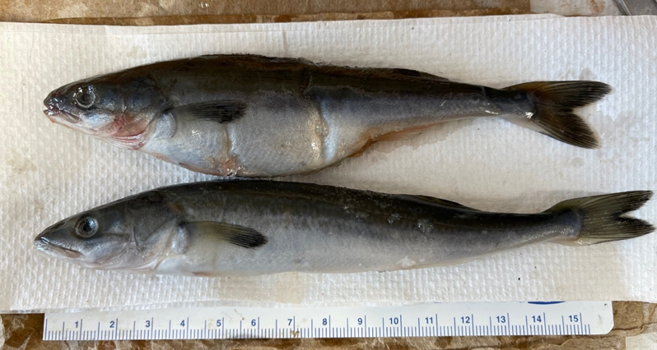

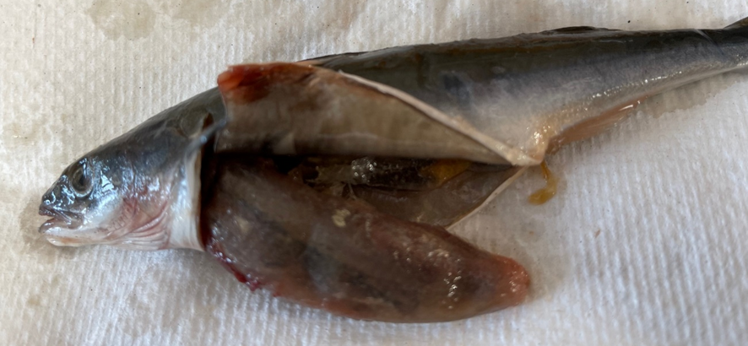

# Figure 1. Stations sampled during National Oceanic Atmospheric Fisheries’ surface trawl surveys in June 1998-2022 by total observations.

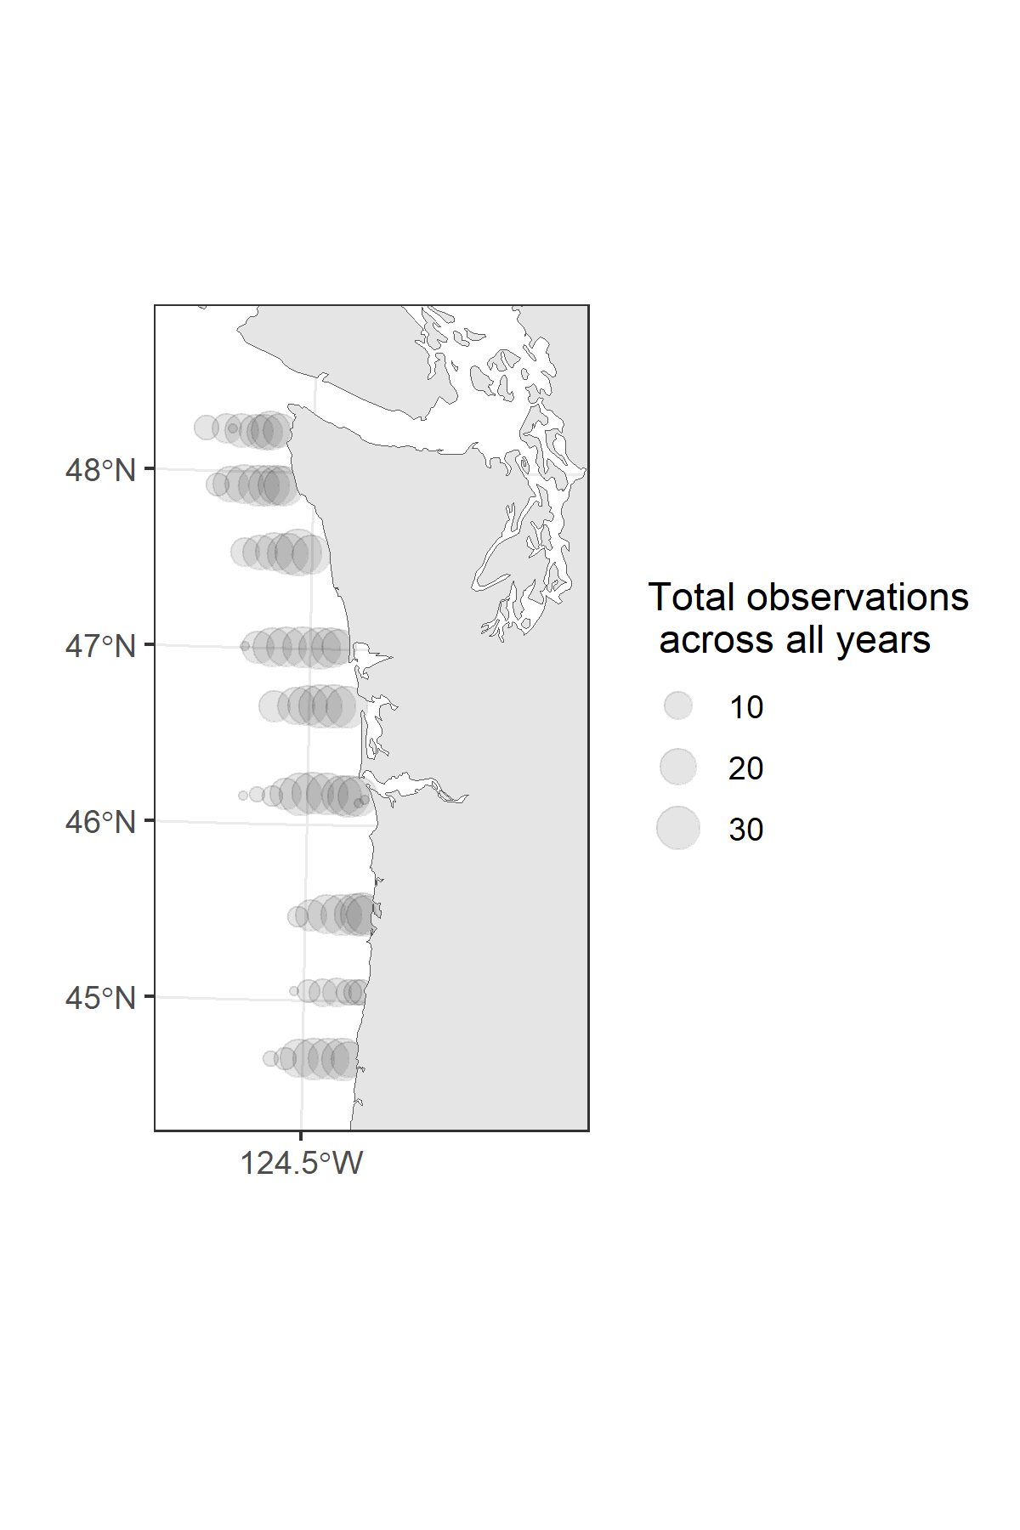

# Figure 2. Fork length (mm) density distribution plots of juvenile Sablefish during their first marine summer: May, June, and September, with all years combined with average fork length (± SD) and sample size in small text.

# Figure 3. Fork length (mm) density distribution plots of juvenile Sablefish sampled in June by year with average (± SD) and sample size.

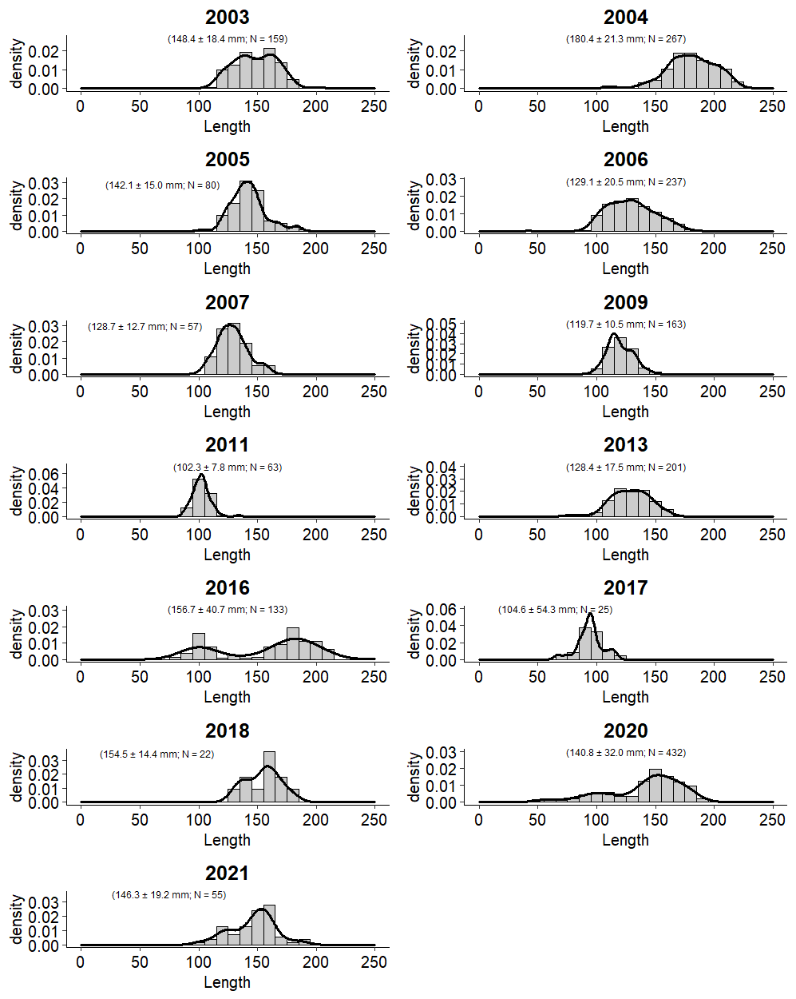

# Figure 4. Ratio (+-90% CI) between annual and mean indexes of abundance (the product of encounter rates and catch rates integrated over the spatial domain of the survey) for the four species categories from 1998 to 2022.

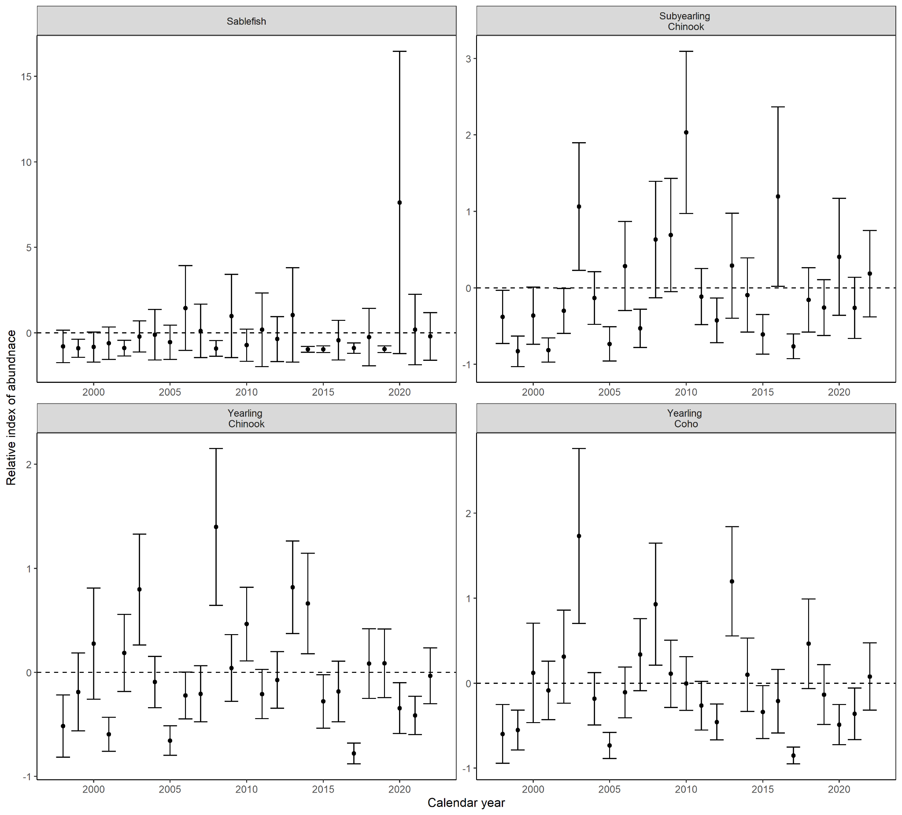

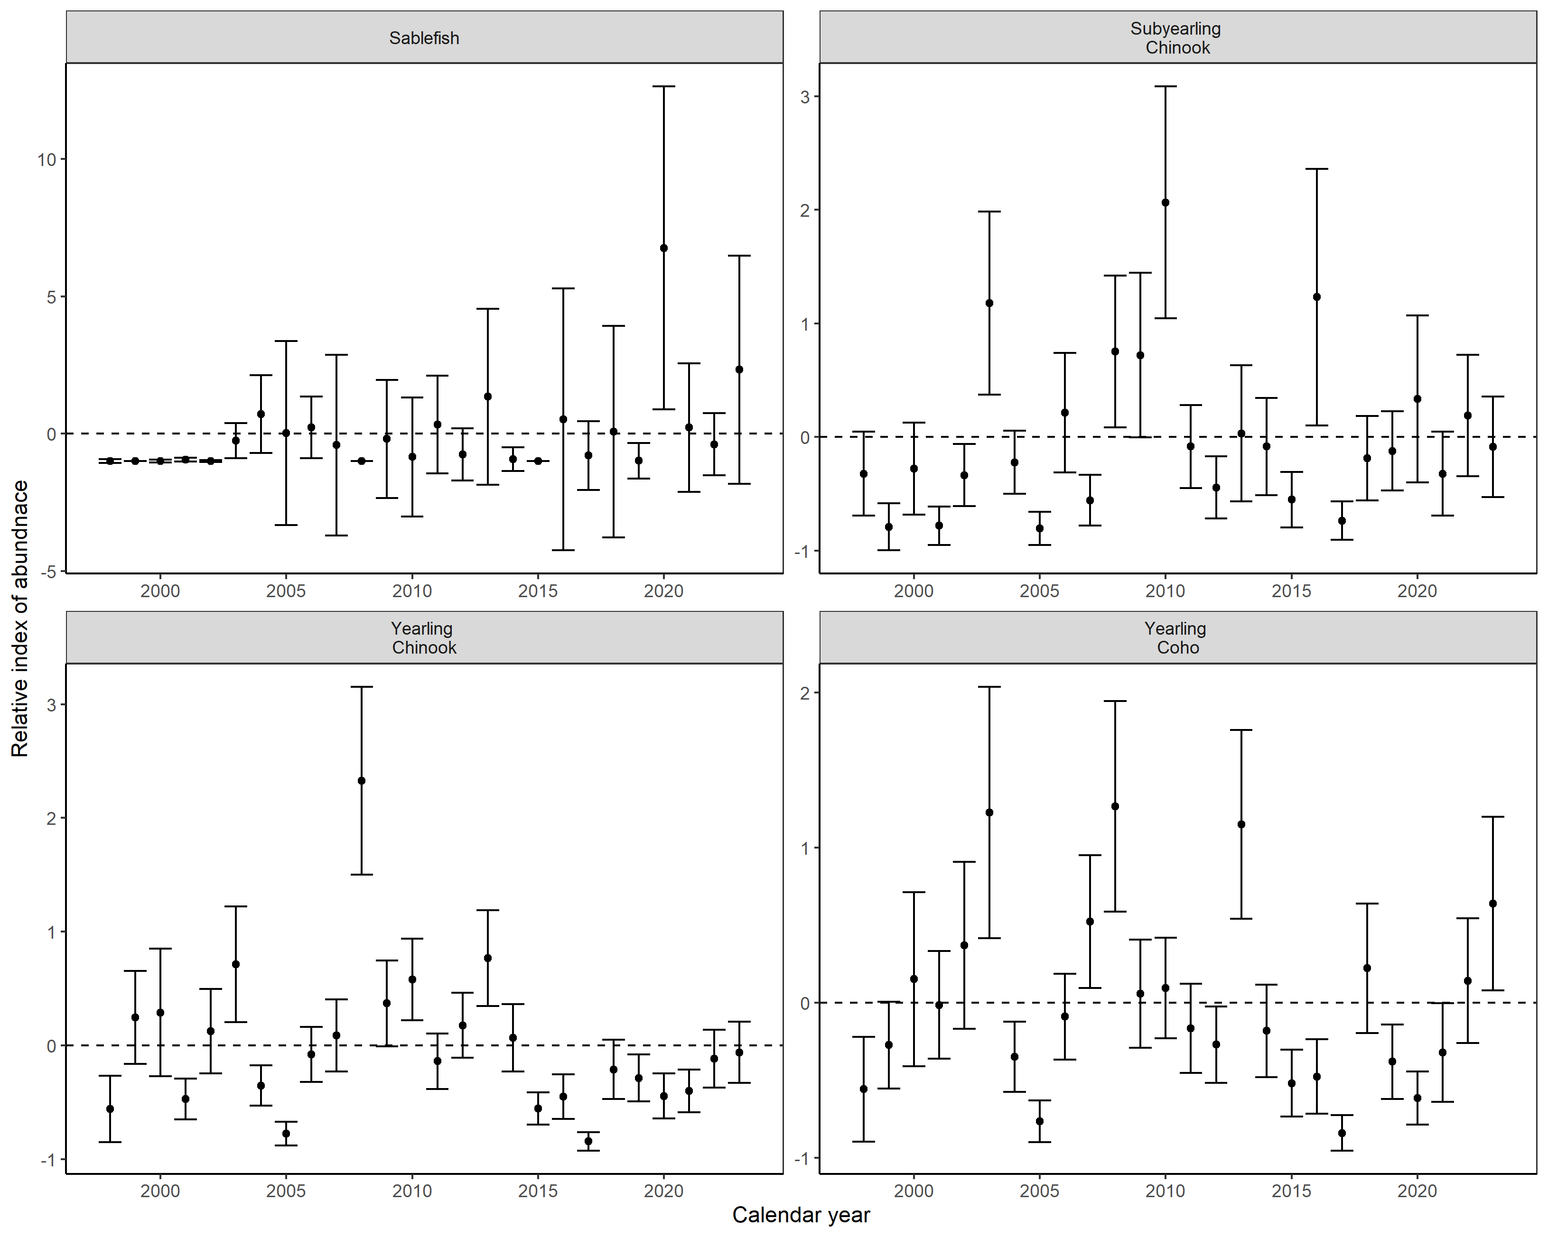

# 

# Figure 5. Estimated densities in an average year and 2020 to 2022. Red points represent locations and size of the log of the observed catches and “+” locations where fish were not captured.

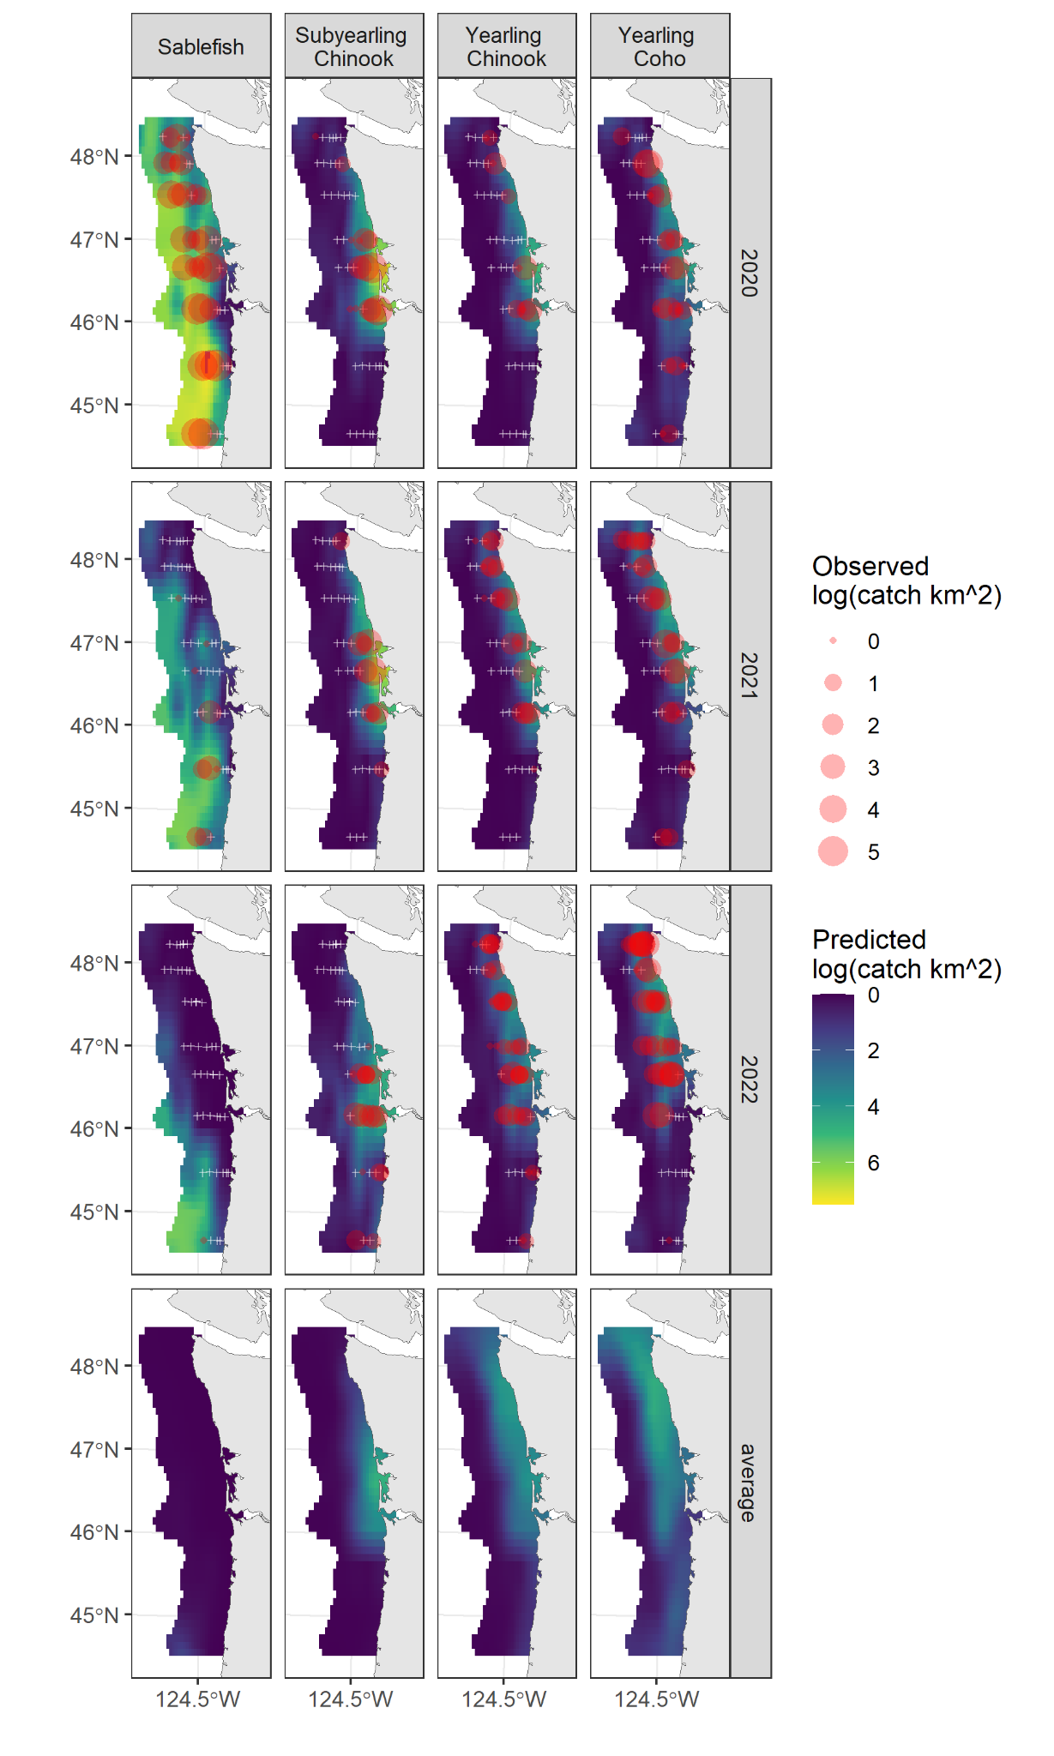

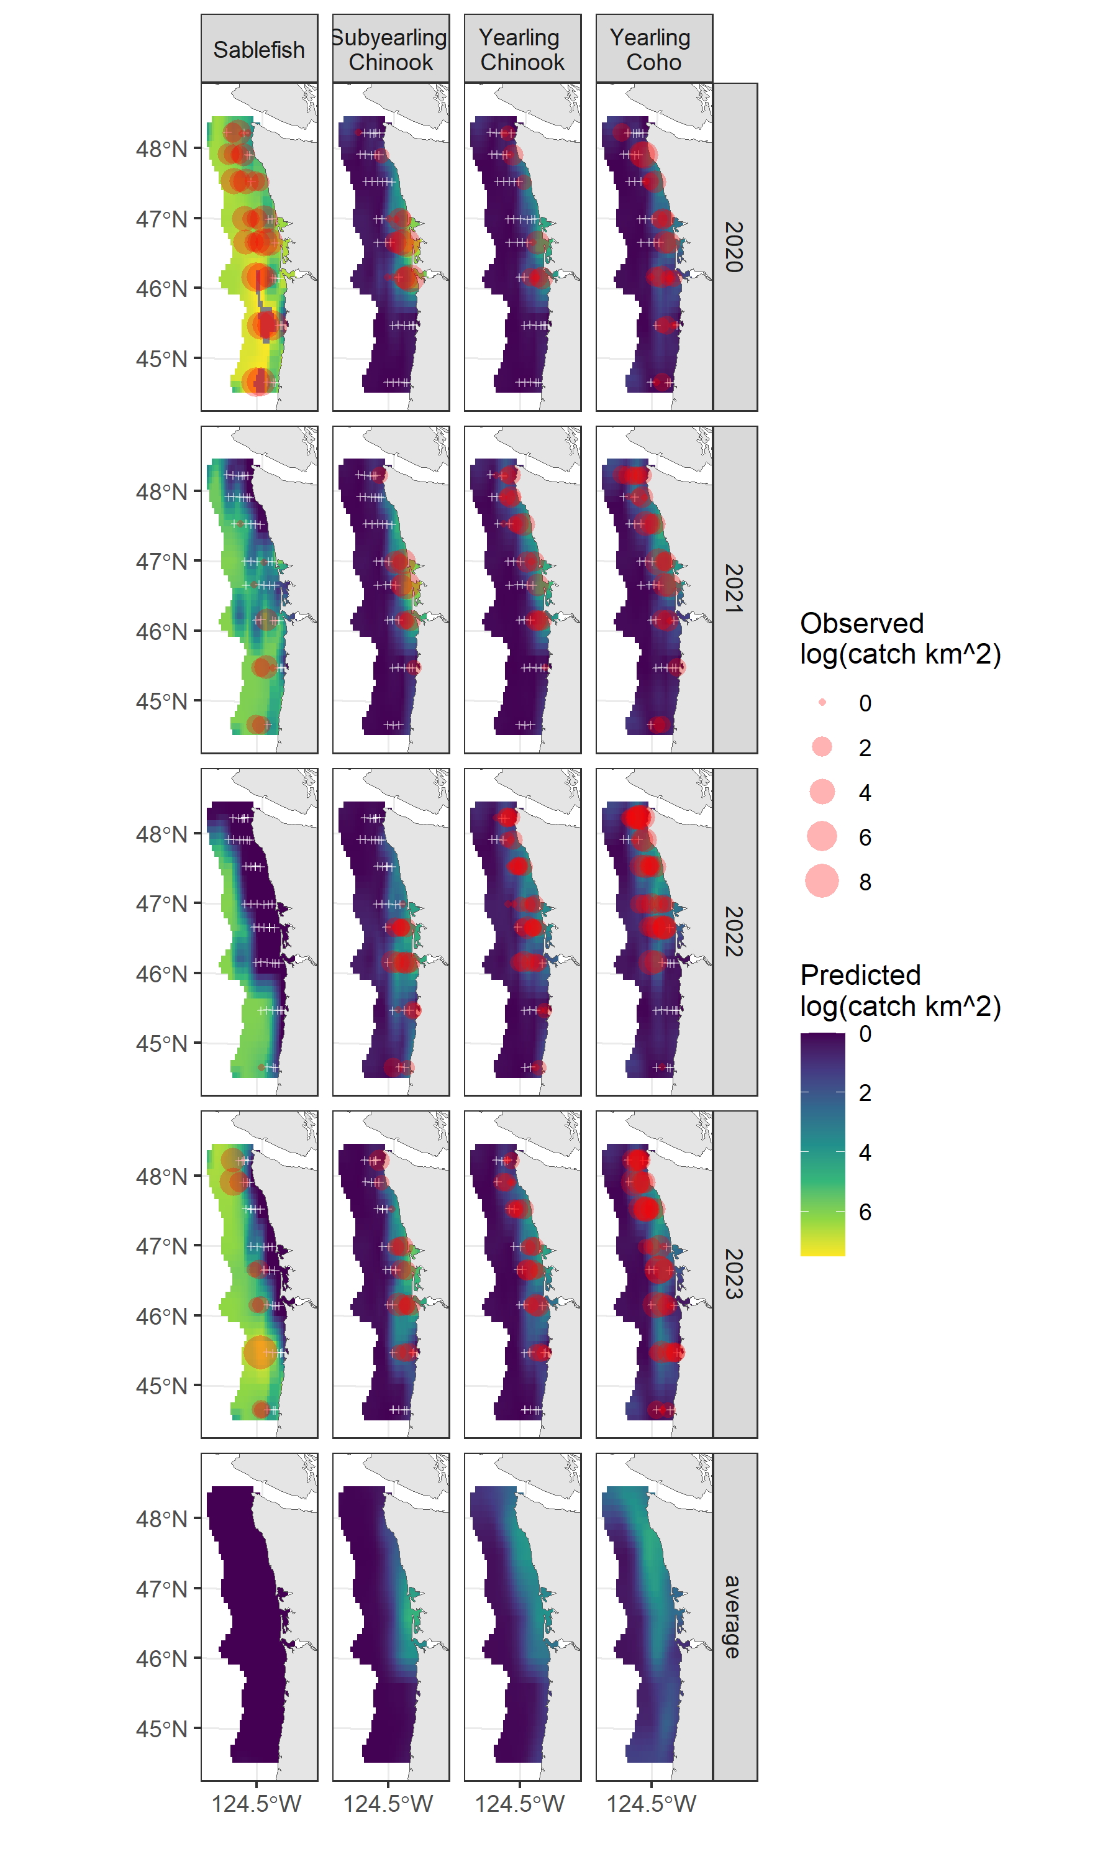

# Figure 6. Non-metric multidimensional scaling ordination of the diet composition of juvenile Sablefish (grey circle), subyearling Chinook Salmon (orange triangle), yearling Chinook Salmon (green plus), and Coho Salmon (blue x). Ellipses encompass the major and minor axes of each species and are the color of the predator as listed above, and the location of prey species (black text) that are most associated with each axis.

# Figure 7. Diet composition of juvenile Sablefish by size-bins based on proportion of prey consumed (wet weight). Vertical line denotes the size where diets were significantly different between the size bins based on SIMPROF analysis.

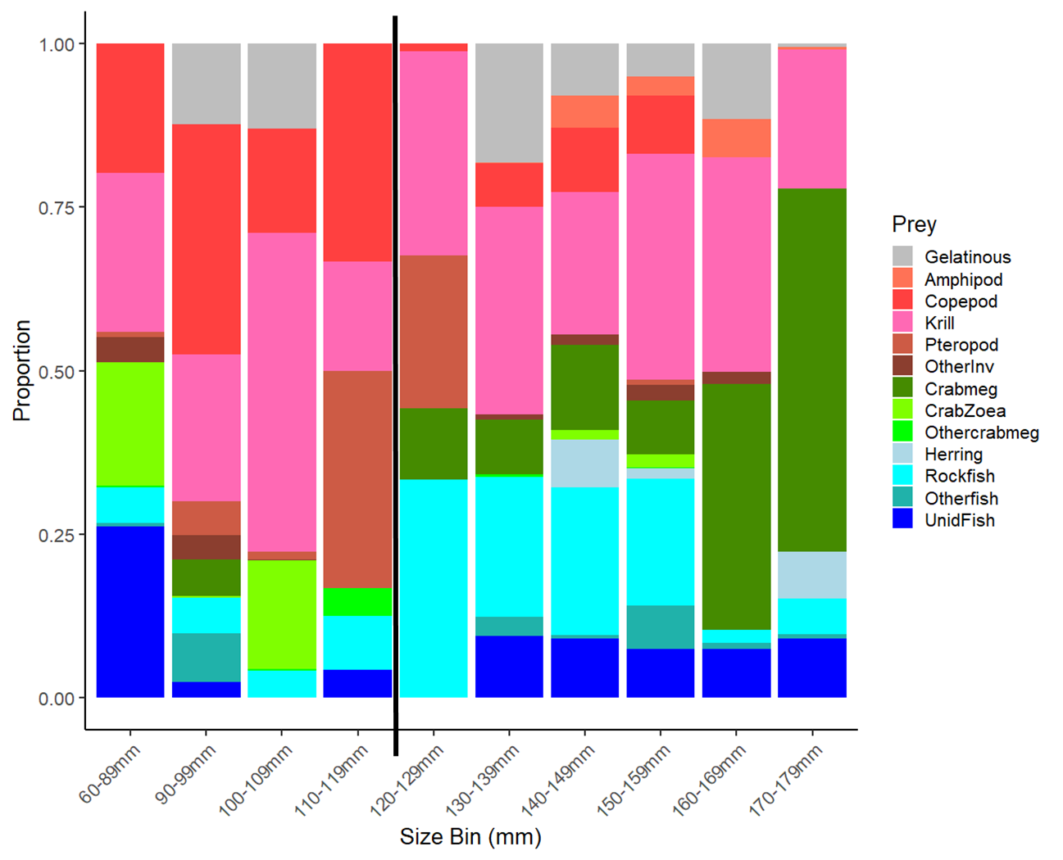

Figure 8. Standardized stomach fullness by fork length for juvenile Sablefish (gray circle), subyearling Chinook Salmon (orange triangle), yearling Chinook Salmon (green plus), and Coho Salmon (blue x) in June 2020.

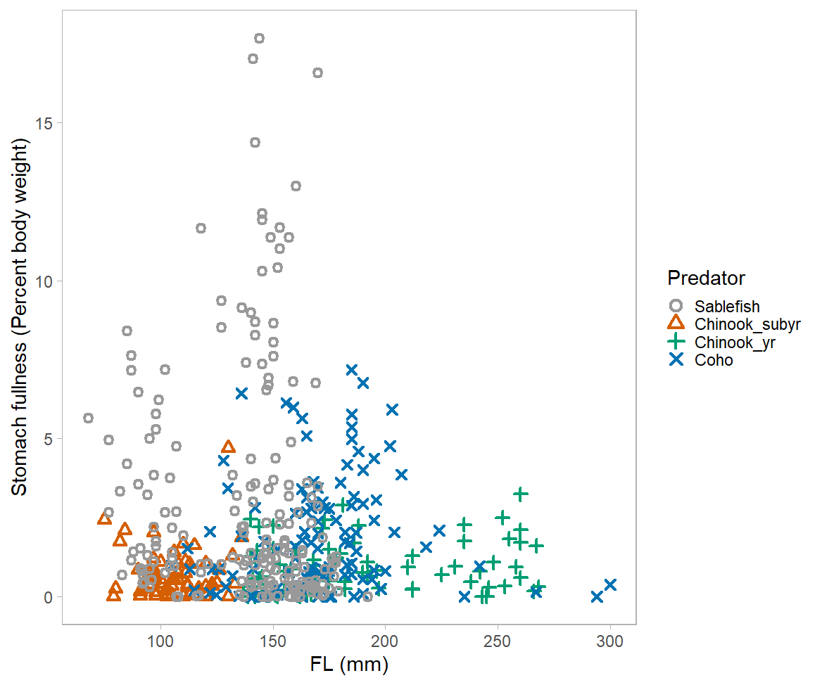

# Figure 9. Standardized stomach fullness of juvenile salmon at sampling stations with and without juvenile Sablefish in June 2020. Significant differences (p < 0.05) between salmon stomach fullness with and without Sablefish is denoted by an asterisk (*). Boxplot displays median and interquartile range with the notch displaying confidence interval around the median, and circles are outliers.

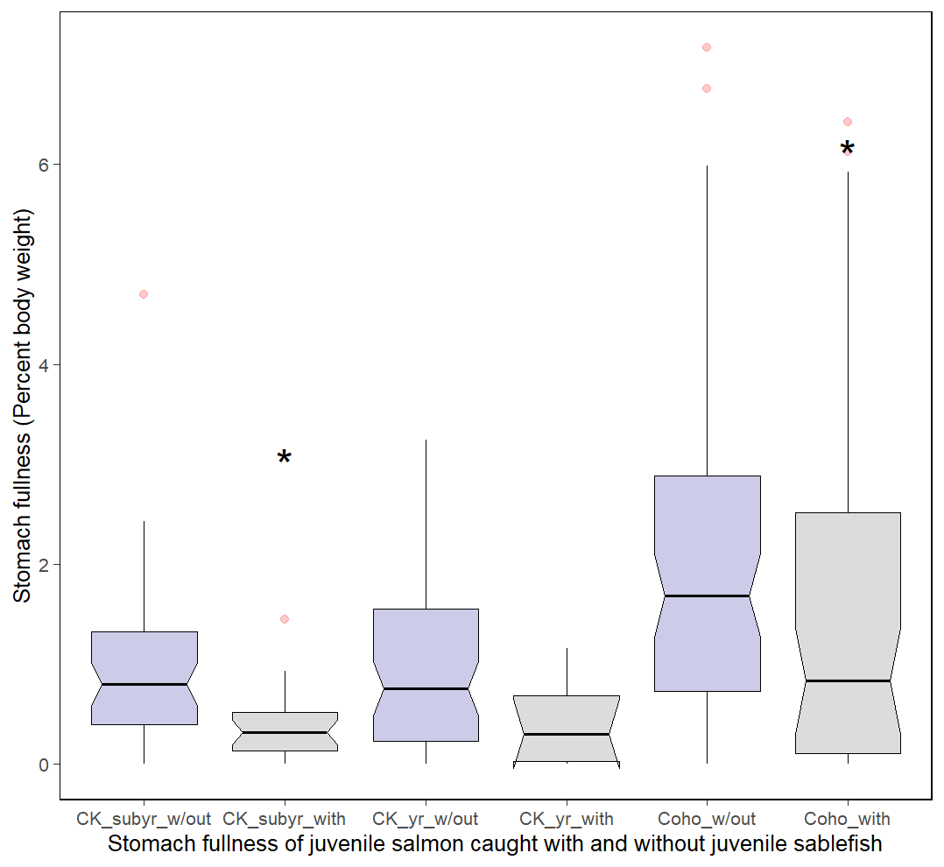

# Figure 10. Fish prey/predator ratio by fork length for juvenile Sablefish (gray circle), yearling Chinook Salmon (green plus), and Coho Salmon (blue x) in June 2020 with juvenile Sablefish (gray text) regression. Too few fresh fish were consumed by subyearling Chinook Salmon to display.

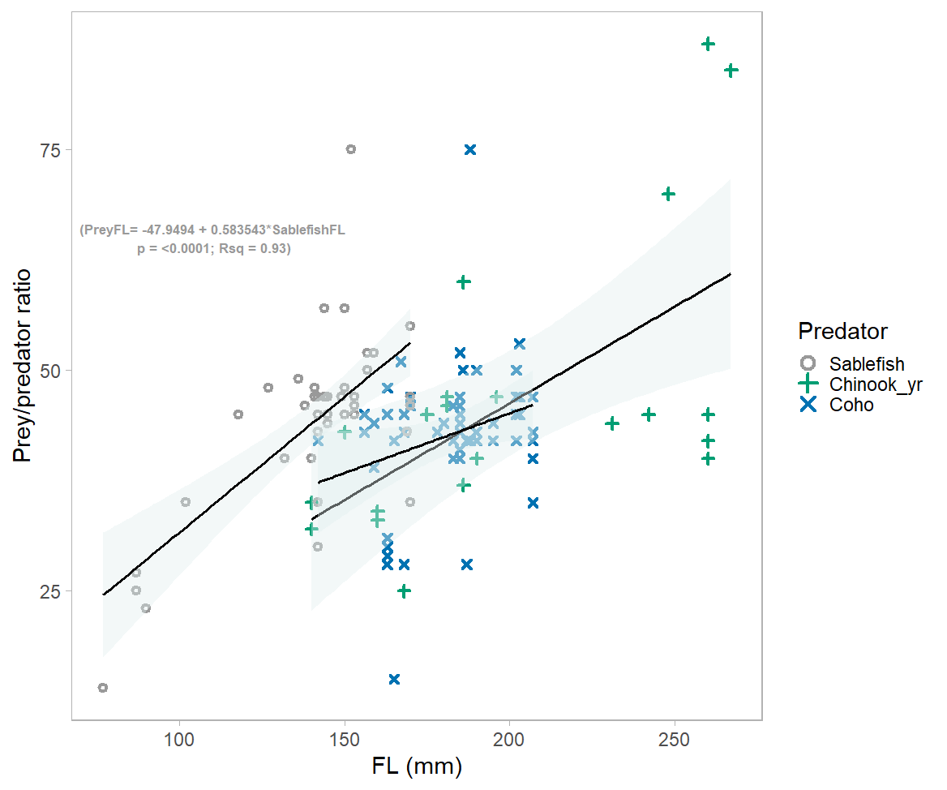

# 

# Supplemental Fig 1. Spatial distribution of the sample locations for the June JSOES survey from 1998 to 2023.

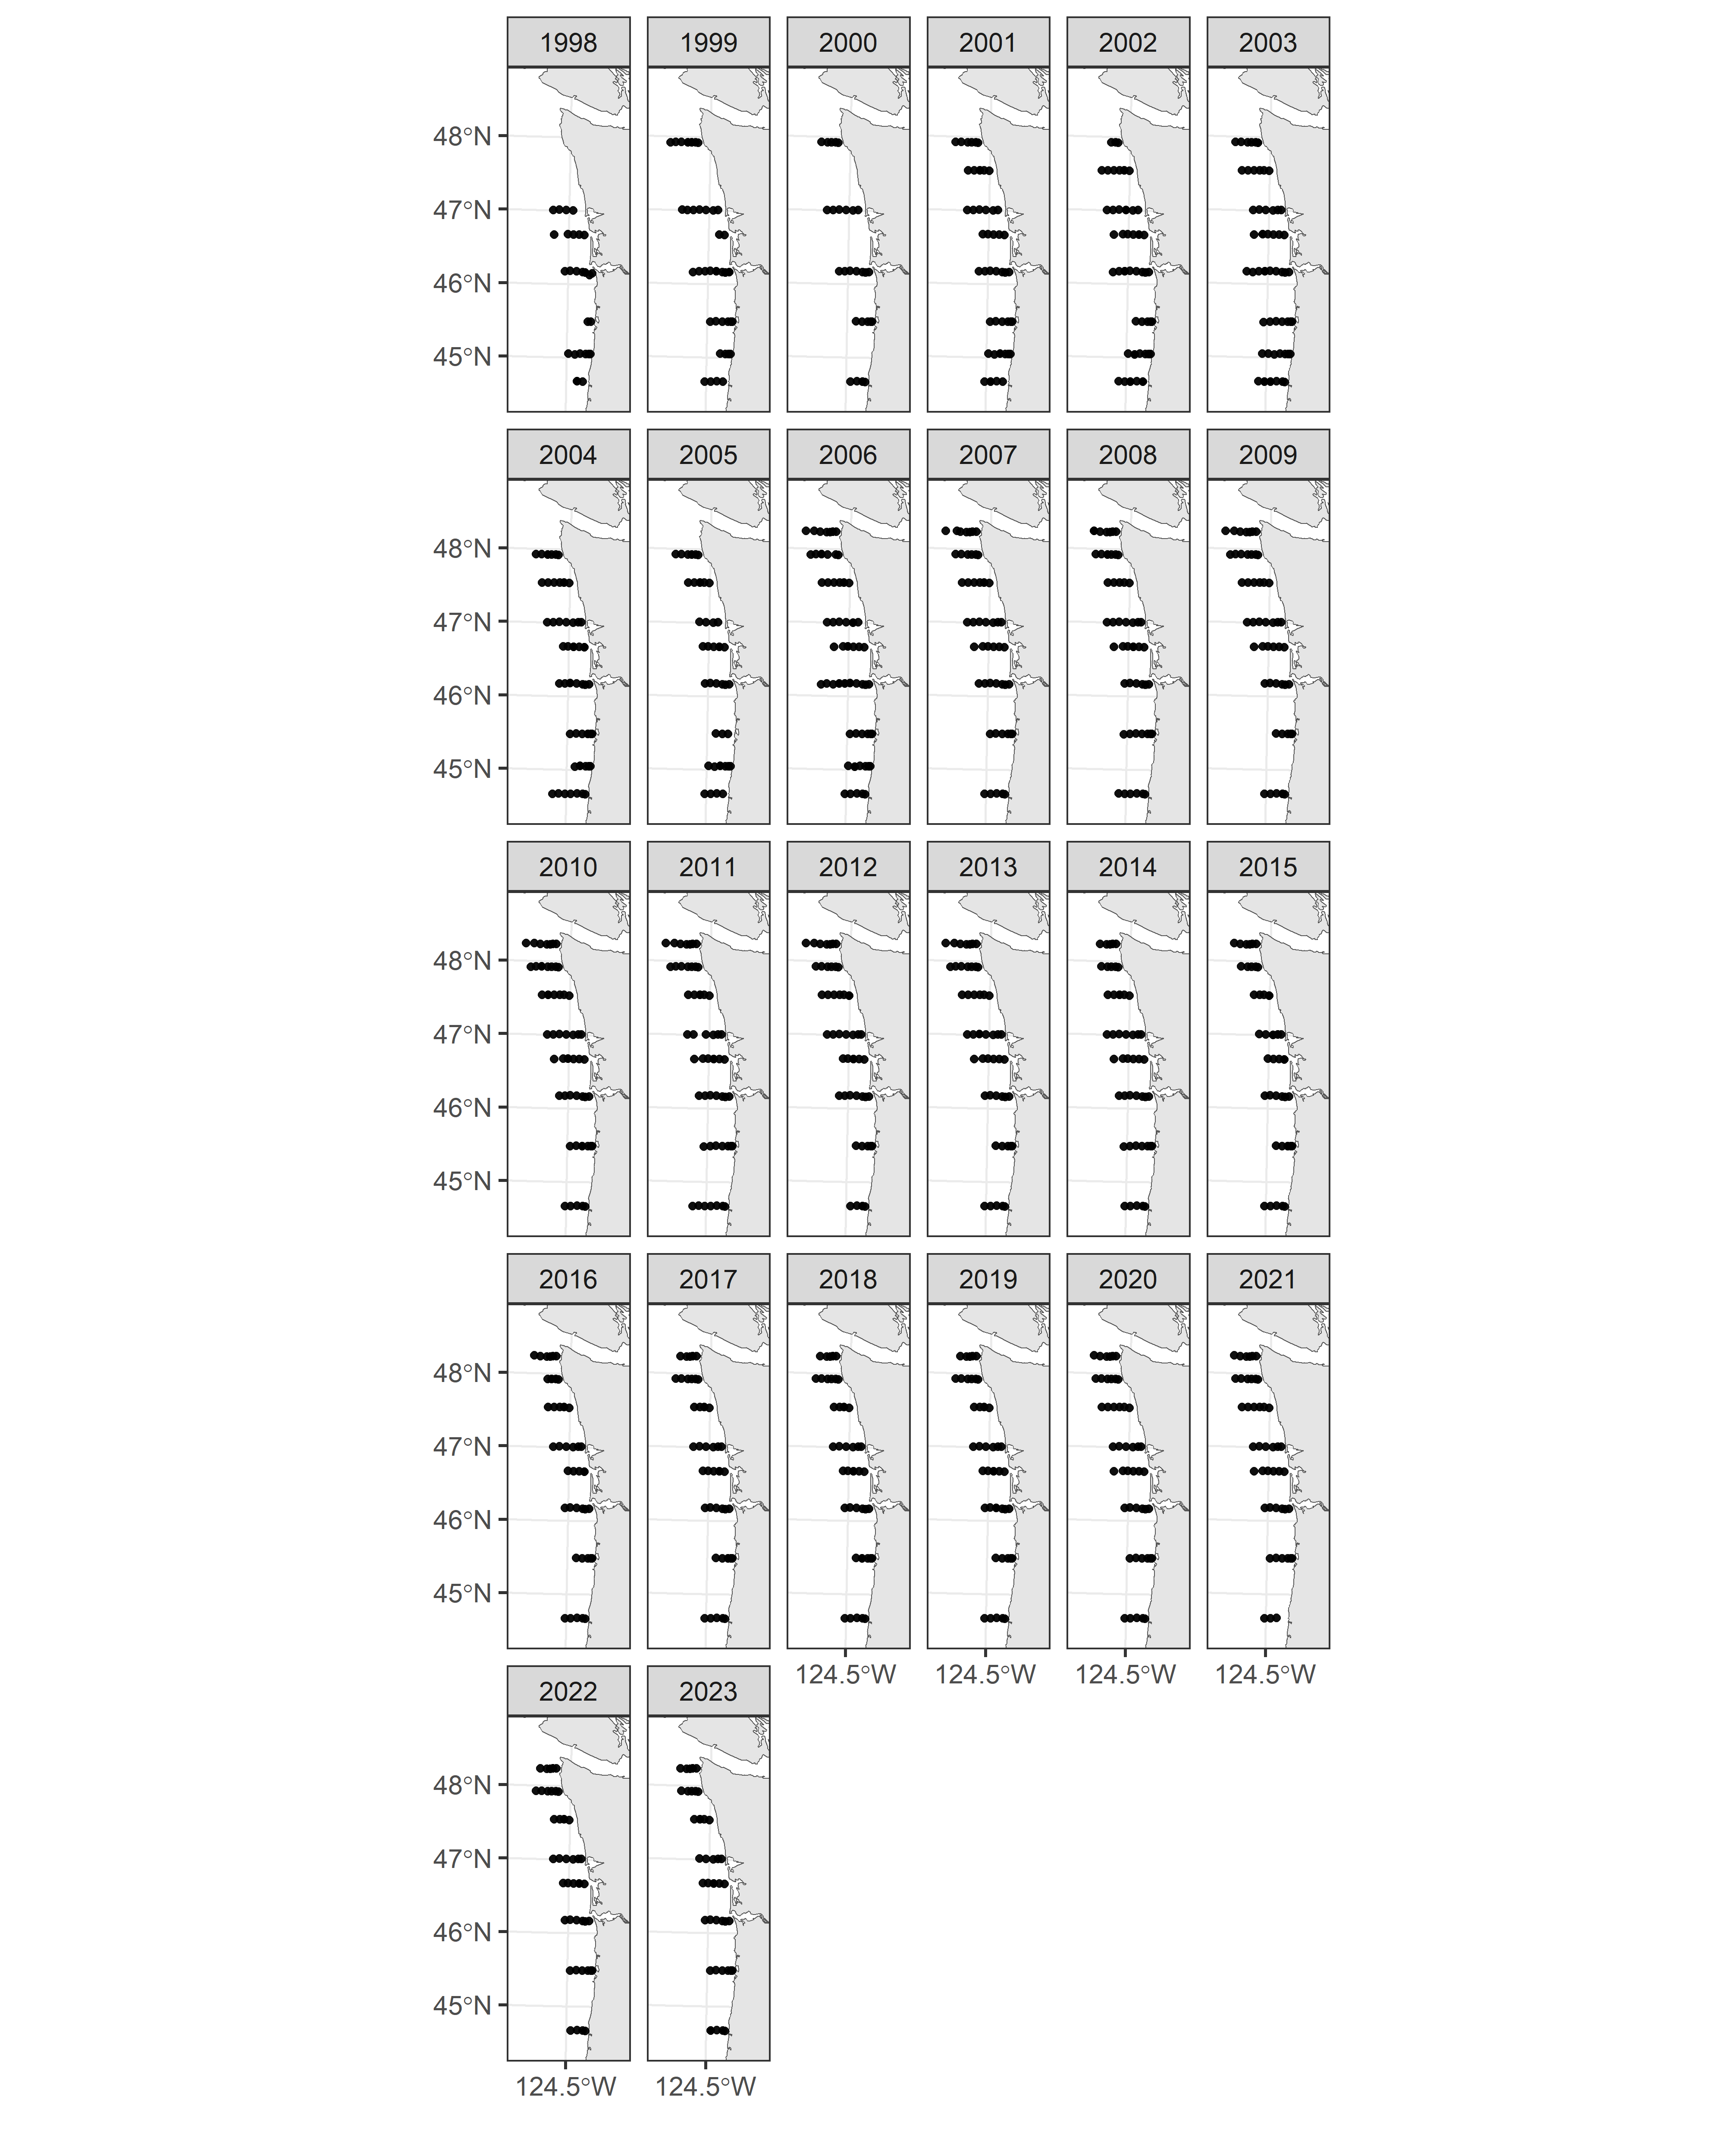

# Supplemental Figure 2. Knot locations for the spatial mesh. The number of knots was set to 68 - the number of unique “station” locations.

# Supplemental Figure 3. Estimated densities from 1998 to 2023 for juvenile subyearling Chinook Salmon. Red points represent locations and size of the log of the observed catches and “+” locations where fish were not captured.

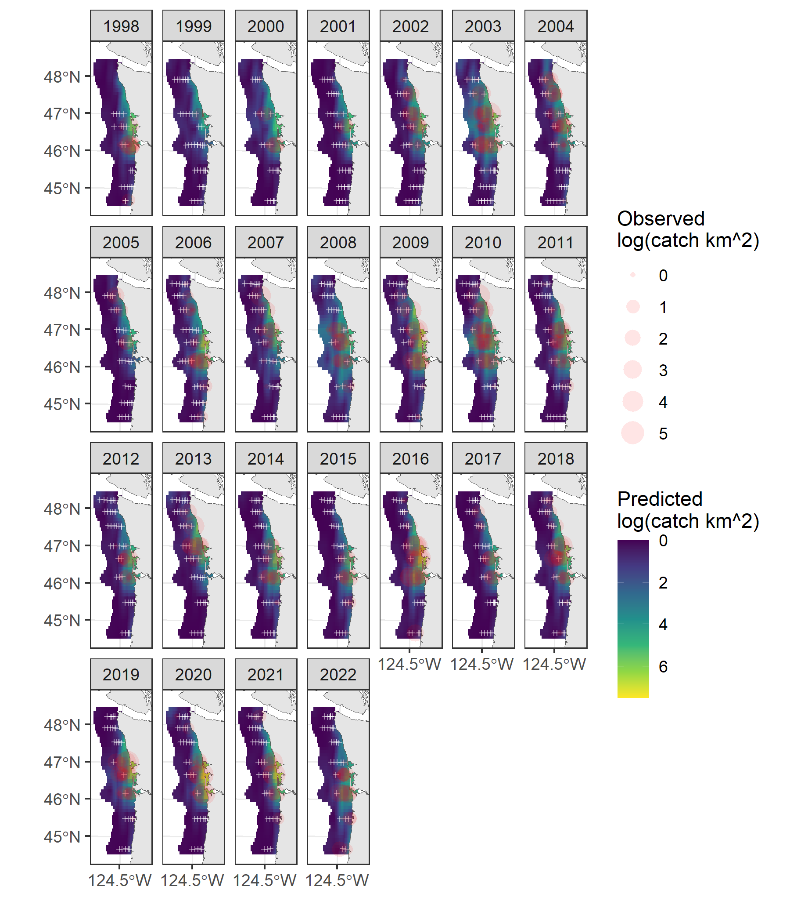

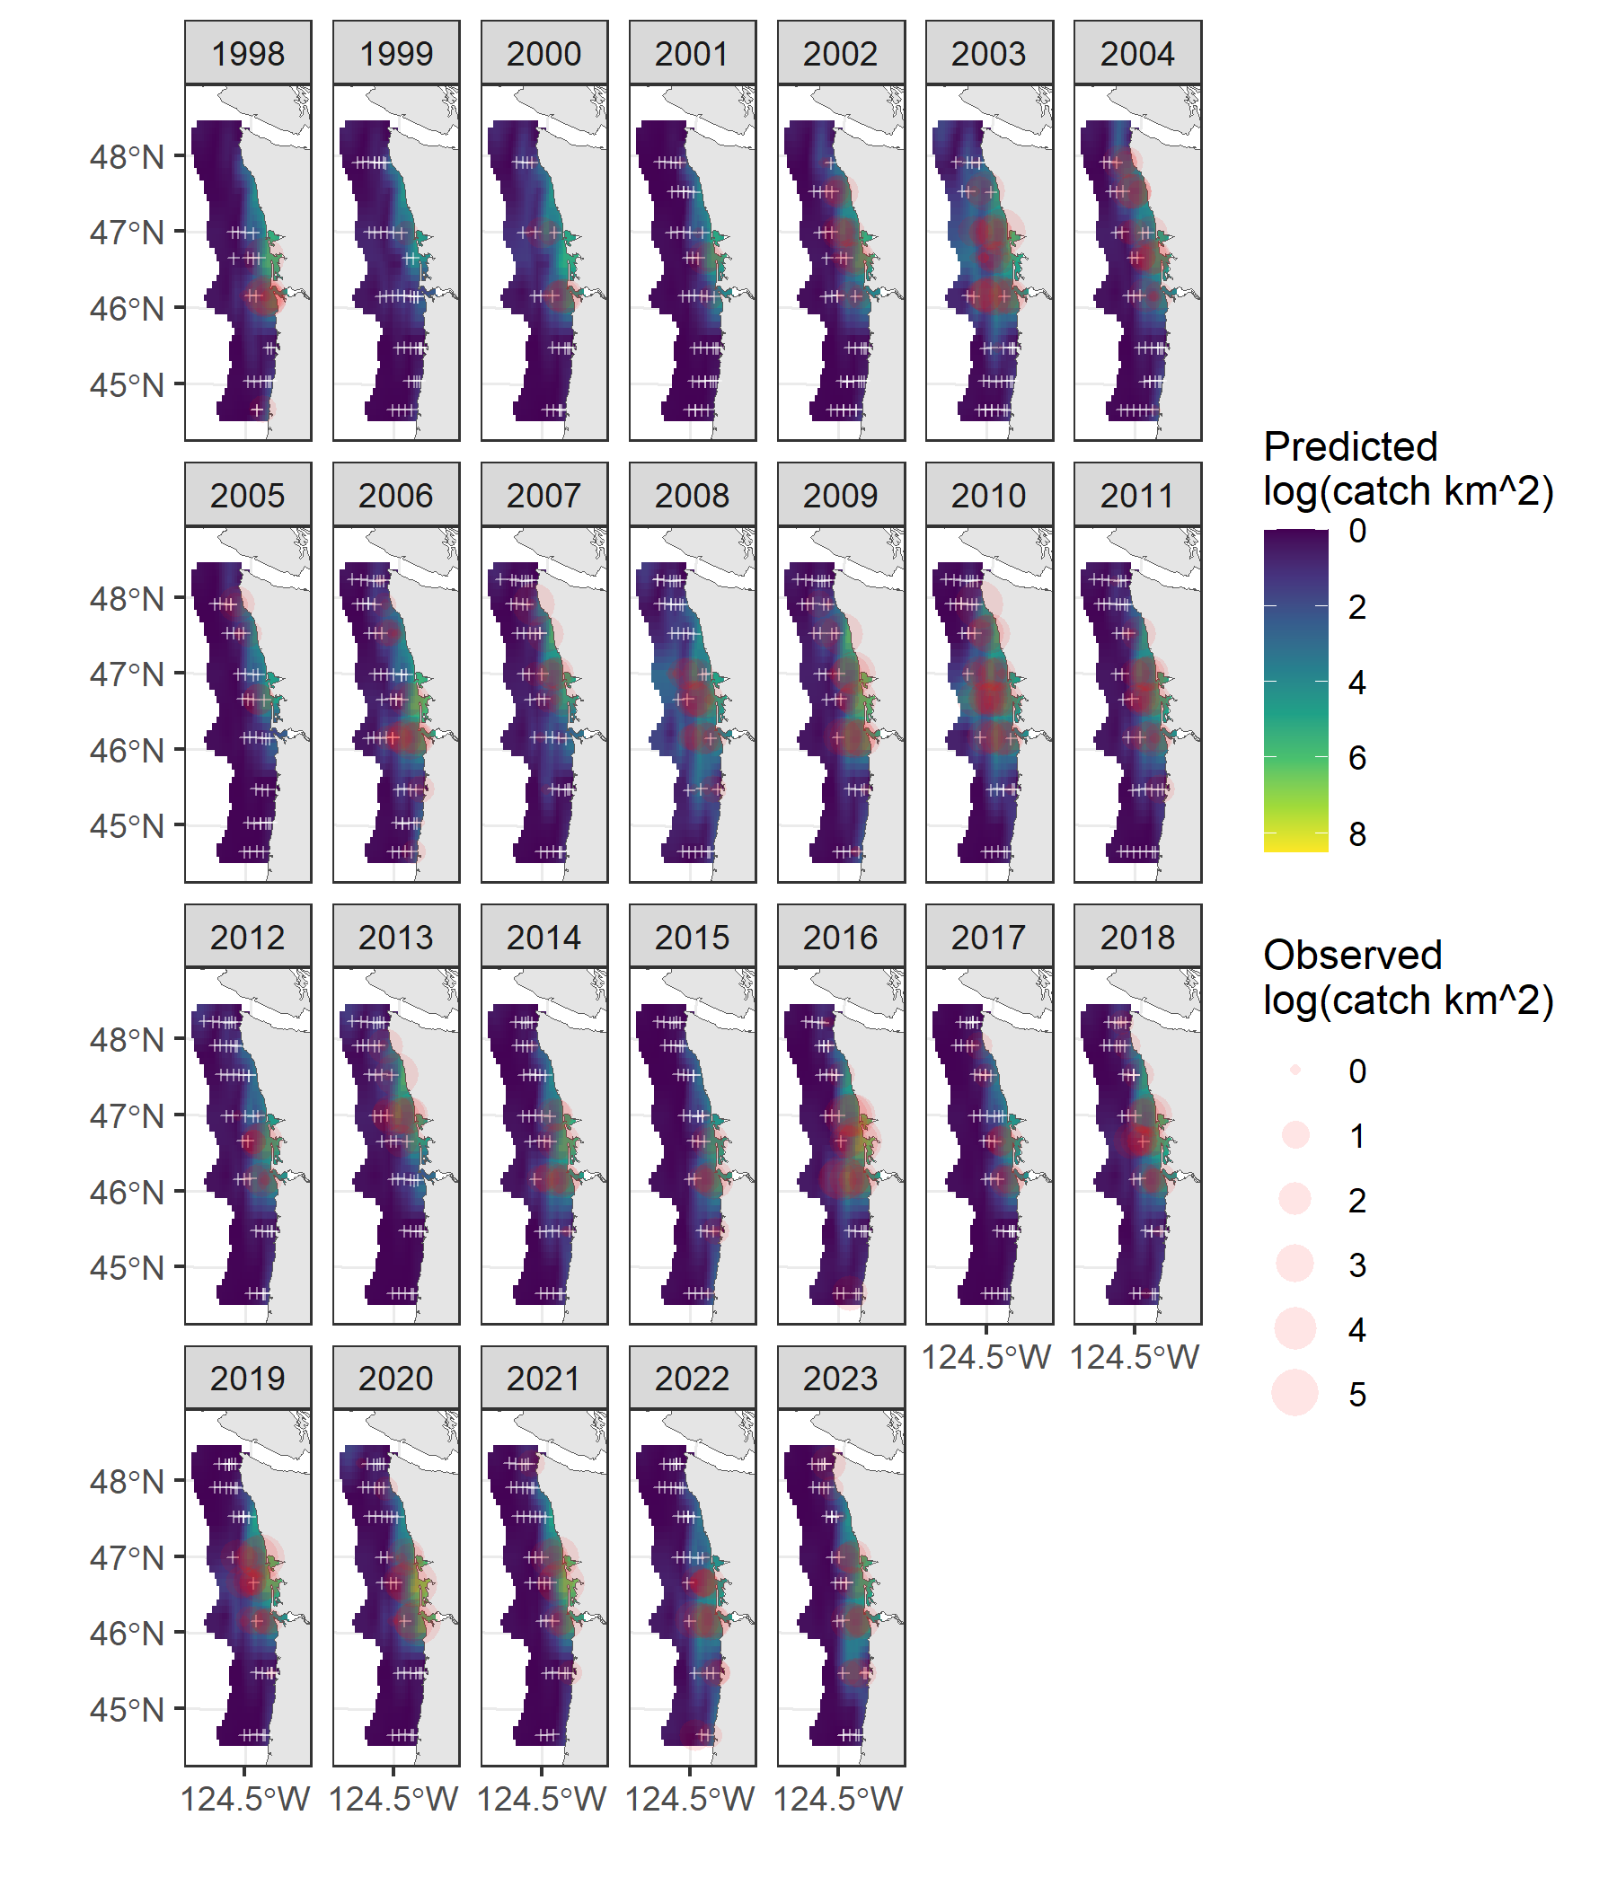

# Supplemental Figure 4. Estimated densities from 1998 to 2022 for juvenile yearling Chinook Salmon. Red points represent locations and size of the log of the observed catches and “+” locations where fish were not captured.

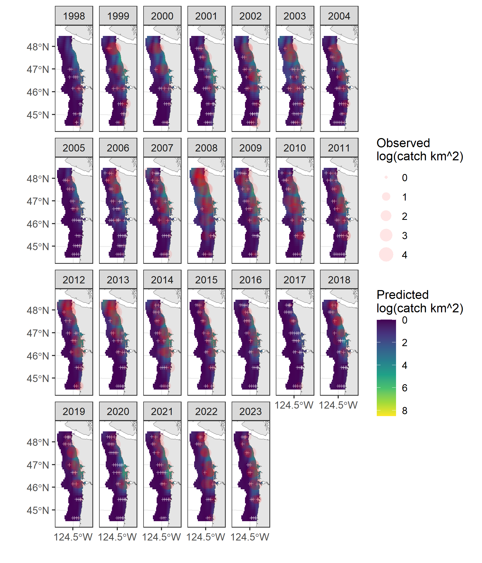

# Supplemental Figure 5. Estimated densities from 1998 to 2022 for juvenile yearling Coho Salmon. Red points represent locations and size of the log of the observed catches and “+” locations where fish were not captured.

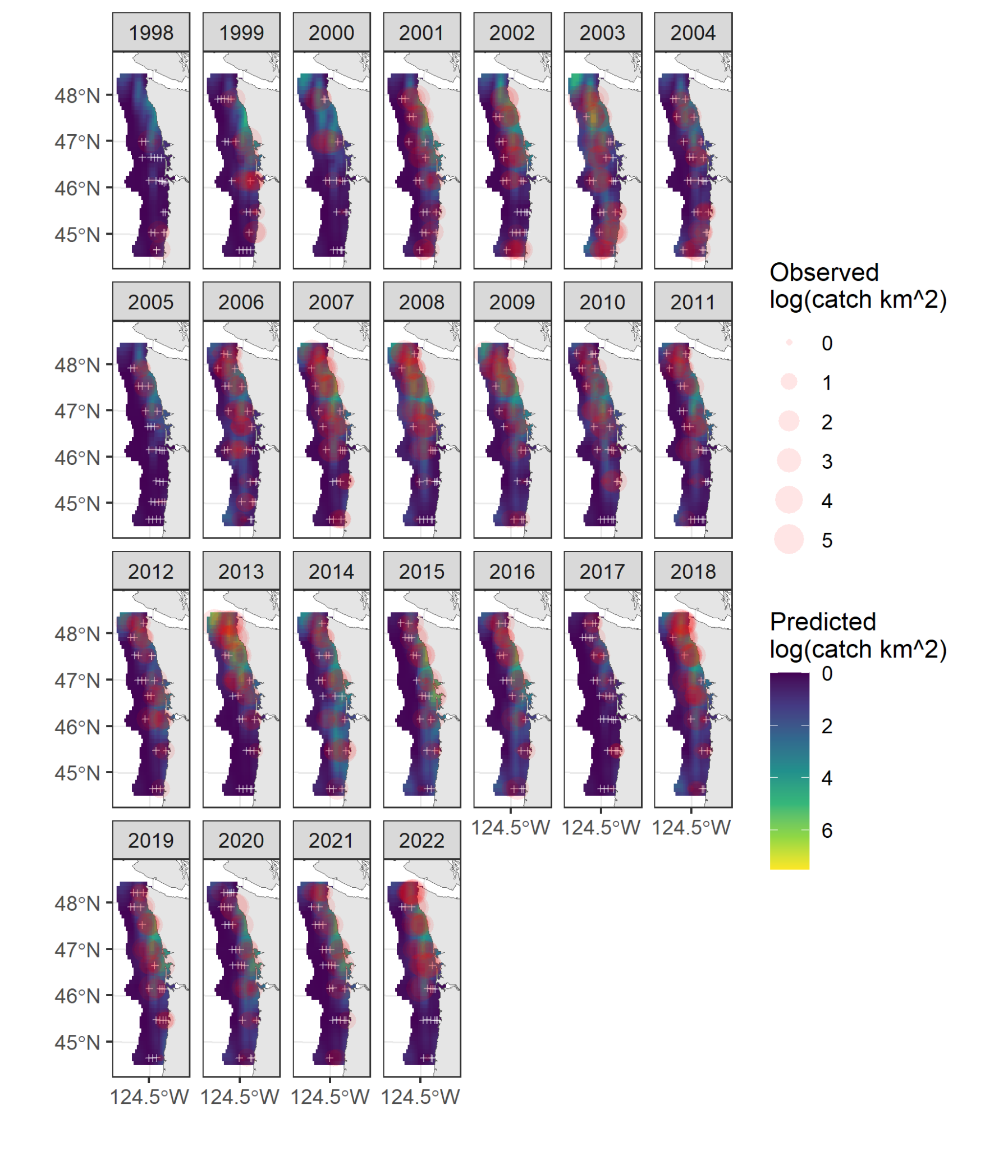

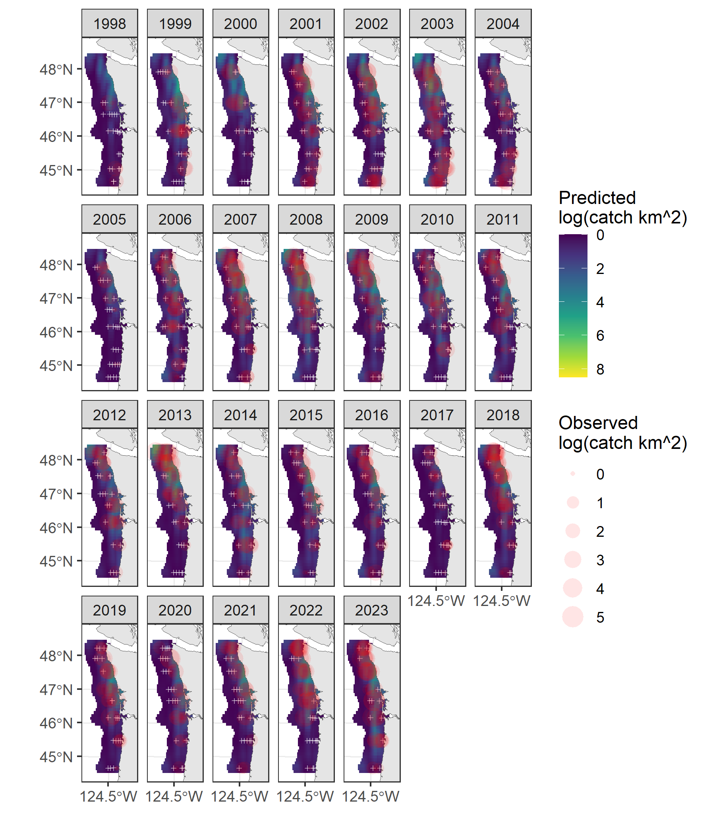

# Supplemental Figure 6. Estimated densities from 1998 to 2022 for juvenile Sablefish. Red points represent locations and size of the log of the observed catches and “+” locations where fish were not captured.

